

**Project Report**

**Team No: 558**

**Project: Web Application Penetration Testing.**

**Team Members:**

**20BCY10001 - Maddirala Shalem Raju**

**20BCY10171 - Meenal Garg**

**20BCY10192 - Sabbavarapu Tejesh**

**20BCY10132 - K Leela Pavan Kumar**

**Under Guidance of:**

Prof. P. Manoj & Smart Internz platform

**Campus:**

VIT - BHOPAL

**CONTENTS**

1. INTRODUCTION ……………………………………………………………………3

1.1 Overview …………………………………………......................................................3

1.2 Purpose ………………………………………………………………………….........4

2. LITERATURE SURVEY………………………………………………………………4

3. THEORITICAL ANALYSIS…………………………………………………………..6

3.1 Hardware ……………………………………………………………………………..6

3.2 Software designing……………………………………………………………………7

4. EXPERIMENTAL INVESTIGATIONS……………………………………………….7

5. RESULT & FINDINGS ………………………………………………………….…….9

6. VULNERABILITY SCANNING AND ASSESSMENT………………………………23

7. ADVANTAGES & DISADVANTAGES …………………………………………….. 46

8. CONCLUSION ……………………………………………………………………… 48

9. FUTURE SCOPE …………………………………………………………………….. 49

10.REFERENCE………………………………………………………………………… 50

**1.INTRODUCTION**

Web application penetration testing, also known as web app pentesting, is the process of assessing the security of a web application by identifying vulnerabilities and weaknesses that could be exploited by attackers. It involves simulating real-world attacks on the application to identify potential entry points and security flaws. Pentesting helps organizations discover vulnerabilities and implement appropriate security measures to protect their web applications and the data they handle.

**1.1 Overview**

The first step in a web application pentesting project is to define the scope. This includes determining the specific web application(s) to be tested, identifying the testing objectives, and defining any limitations or constraints.

In this phase, the pentester collects as much information as possible about the target application. This includes understanding the application's architecture, technologies used, APIs, server details, and any available documentation. The pentester may also perform reconnaissance activities like open-source intelligence (OSINT) gathering to gather information about the target organization and its web presence.

The pentester analyzes the gathered information to identify potential threats and attack vectors specific to the web application. This helps in prioritizing the testing efforts and focusing on the most critical areas.

Automated vulnerability scanning tools are used to scan the target application for known vulnerabilities and common security misconfigurations. These tools can identify issues such as outdated software versions, insecure configurations, or missing patches.

Manual testing involves a hands-on approach where the pentester manually probes the application for vulnerabilities. Techniques such as input validation testing, authentication and authorization testing, session management testing, and error handling testing are performed. The goal is to identify vulnerabilities that may not be easily detected by automated tools.

Once vulnerabilities are identified, the pentester attempts to exploit them to demonstrate the potential impact of an attacker gaining unauthorized access or performing malicious activities. However, the exploitation is done within the predefined boundaries and agreed-upon rules of engagement.

A comprehensive report is generated detailing the findings, including the identified vulnerabilities, their impact, and recommended remediation actions. The report typically includes an executive summary, technical details, and supporting evidence such as screenshots or proof-of-concept code. The report helps the organization understand the risks associated with their web application and take appropriate measures to address them.

The organization addresses the identified vulnerabilities based on the recommendations provided in the report. Once the fixes are implemented, a retest is conducted to verify that the vulnerabilities have been effectively remediated.

Web application security is an ongoing process. Regular monitoring and periodic pentesting help ensure that new vulnerabilities are promptly identified and addressed. It is recommended to conduct pentesting after major updates or changes to the application to maintain a robust security posture.Our project focuses on conducting a comprehensive web application penetration testing on a website *vitbhopal.ac.in*. The goal is to identify potential vulnerabilities and security weaknesses that could be exploited by attackers to gain unauthorized access, steal sensitive information, or disrupt the website's functionality. The project involves a step-by-step process that includes scoping, information gathering, threat modeling, vulnerability scanning, manual testing, exploitation (within predefined boundaries), reporting, remediation, and verification as in our overview.

If vulnerabilities are discovered, we attempt to exploit them within the predefined boundaries and agreed-upon rules of engagement. The goal is to demonstrate the potential impact of these vulnerabilities and provide concrete evidence to support our findings.

Overall, web application pentesting plays a vital role in assessing the security posture of web applications and helps organizations proactively identify and mitigate vulnerabilities before they can be exploited by malicious actors.

**1.2 Purpose**

The purpose of a web application penetration testing project is to assess the security posture of a web application and identify vulnerabilities that could be exploited by malicious actors. By conducting thorough testing and analysis, the project aims to achieve the objectives such as Identifying vulnerabilities, Assess security controls, Measure compliance, Prioritize remediation efforts, Enhance security posture and Increase customer trust.

Overall, the project aims to strengthen the security posture of the web application, mitigate risks, protect sensitive data, comply with regulations, and maintain customer trust. It provides organizations with valuable insights into their security vulnerabilities and enables them to take proactive measures to address those vulnerabilities and improve their overall security resilience. Our project helps organizations improve their incident response preparedness by identifying vulnerabilities and potential attack vectors, the project enables organizations to anticipate and plan for potential security incidents. This includes developing response plans, implementing monitoring and detection systems, and training staff to effectively respond to and mitigate security breaches or attacks.

**LITERATURE SURVEY**

A literature survey for a project on web application pentesting on a website would involve researching and reviewing existing literature, academic papers, research studies, and industry publications related to web application security and pentesting.

By conducting a thorough literature survey, you can gather valuable insights, knowledge, and references from existing research and publications. It will provide a solid foundation for your project on web application pentesting and help you stay informed about the latest developments in the field.

While web application penetration testing is a crucial practice for assessing the security of web applications, it is not without its challenges and existing problems. Some of the common problems encountered in web application pentesting include:

* **Lack of Testing Coverage:**

Due to the complexity of modern web applications, it can be challenging to achieve comprehensive testing coverage. Various layers, technologies, and functionalities within the application may be overlooked, leaving potential vulnerabilities undetected.

**Solution:**

Implement a comprehensive testing approach that covers all layers, technologies, and functionalities of the web application. This can involve conducting a thorough scoping exercise, identifying critical components, and ensuring proper testing coverage across the application.

* **False Positives and False Negatives:**

Automated vulnerability scanning tools used in web application pentesting may generate false positives, flagging issues that do not actually exist. On the other hand, false negatives can occur when vulnerabilities are not detected by the tools, leading to a false sense of security.

**Solution:**

Validate and tune automated vulnerability scanning tools to reduce false positives and false negatives. Regularly update and configure the tools to improve their accuracy and effectiveness in identifying vulnerabilities.

* **Time Constraints:**

Pentesting projects often face time constraints, which can limit the depth and thoroughness of the testing process. As a result, certain vulnerabilities may be missed or not adequately explored. **Solution:**

Allocate sufficient time for the pentesting project to ensure a thorough and detailed assessment. Consider the complexity of the application and allocate time accordingly to allow for comprehensive testing and in-depth analysis.

* **Lack of Documentation:**

Inadequate documentation or limited access to the application's source code and architecture can pose challenges during pentesting. It may hinder the understanding of the application's functionalities and increase the difficulty of identifying vulnerabilities.

**Solution:**

Ensure that proper documentation of the web application, including architecture, functionalities, and relevant information, is available to the pentesting team. Establish communication channels with developers and stakeholders to clarify any ambiguities and facilitate knowledge transfer.

* **Lack of Standardized Methodologies:**

Although there are established methodologies for web application pentesting (such as the OWASP Testing Guide), there is still a lack of standardization across the industry. Different pentesters may follow different approaches, making it challenging to compare and assess the quality and effectiveness of the testing.

**Solution:**

Promote the use of standardized methodologies, such as the OWASP Testing Guide, to ensure consistency and comparability in web application pentesting practices. Encourage the adoption of industry best practices and frameworks to enhance the quality and effectiveness of testing.

* **Limited Testing Environment:**

Pentesting is typically conducted in a controlled testing environment, which may not accurately reflect real-world scenarios. This can result in potential vulnerabilities being overlooked or the impact of identified vulnerabilities not fully assessed.

**Solution:**

Create a testing environment that closely resembles the production environment to simulate real-world scenarios. Use representative data, configurations, and network setups to better assess the impact of vulnerabilities and validate the effectiveness of security controls.

* **Evolving Threat Landscape:**

The evolving threat landscape poses a continuous challenge in web application pentesting. New vulnerabilities, attack techniques, and emerging technologies require constant adaptation and staying up-to-date with the latest security trends and vulnerabilities.

**Solution:**

Stay updated with the evolving threat landscape by investing in continuous learning and professional development for pentesters. Encourage participation in conferences, training programs, and communities to acquire new skills and knowledge about emerging vulnerabilities and attack techniques.

* **Integration with Development Lifecycle:**

Pentesting is often performed as a one-time activity, rather than integrated into the software development lifecycle. Lack of collaboration between development and security teams can result in delayed vulnerability detection and remediation.

**Solution:**

Foster collaboration and integration between development and security teams throughout the software development lifecycle. Embed security practices, including pentesting, into the development process to identify and address vulnerabilities early on. Implement processes for regular communication, knowledge sharing, and joint efforts in vulnerability remediation.

Addressing these problems requires a combination of technical solutions, process improvements, and continuous education and training of professionals involved in web application pentesting. Efforts such as refining testing methodologies, improving automation tools, fostering collaboration between development and security teams, and promoting knowledge sharing within the industry can help overcome these challenges and enhance the effectiveness of web application pentesting.

By implementing these proposed solutions, organizations can enhance the effectiveness, coverage, and accuracy of web application pentesting. This, in turn, leads to better identification and mitigation of vulnerabilities, improved overall security posture, and reduced risk of successful attacks on web applications.

**3.THEORITICAL ANALYSIS:**

**3.1Hardware:**

Computer System: A capable computer system is essential for running the necessary tools and software. It should have sufficient processing power, memory, and storage capacity to handle the testing environment effectively.

Operating System: You will need a supported operating system, such as Windows, macOS, or Linux, installed on your testing machine. The choice of the operating system may depend on your familiarity and preference, as well as the specific tools you plan to use.

Network Adapter: A network adapter is required to connect your testing machine to the network and communicate with the Metasploitable machine. Ensure that your network adapter supports the required network protocols, such as Ethernet or Wi-Fi.

Virtualization Software: Metasploitable is often run as a virtual machine (VM) using virtualization software. Popular options include VMware Workstation, VirtualBox, or Hyper-V. Install the virtualization software of your choice, ensuring it is compatible with your operating system.

Additional Machines: Depending on your testing requirements, you may need multiple machines to create a comprehensive testing environment. These machines can act as attackers, victims, or network devices to simulate different scenarios and test the vulnerabilities present in

Metasploitable.

Networking Equipment: Depending on the complexity of your testing environment, you may require networking equipment such as switches, routers, or network cables to create a local network for testing purposes. This allows you to isolate the testing environment and prevent any unintended impact on your production network.

External Devices: In some cases, you may need additional hardware devices, such as USB adapters, wireless network cards, or specialized testing equipment, to perform specific tests or simulate certain attack vectors.

**3.2 Software:**

Metasploit Framework: Metasploit is a widely used penetration testing framework that provides a comprehensive set of tools and exploits to assess the security of systems. It includes a large collection of exploits, payloads, and auxiliary modules that can be utilized to identify and exploit vulnerabilities in the Metasploitable machine.

Nmap: Nmap is a powerful network scanning tool that allows you to discover open ports, identify running services, and gather information about the target system. It is often used in combination with Metasploit for reconnaissance and vulnerability assessment.

Nessus: Nessus is a vulnerability scanner that helps identify potential security flaws in systems. It can perform both local and remote vulnerability checks, and provides detailed reports on discovered vulnerabilities. Nessus is commonly used to scan the Metasploitable machine for known vulnerabilities.

Burp Suite: Burp Suite is an integrated platform for performing web application security testing. It includes various tools such as a web proxy, scanner, and intruder, which can be utilized to identify and exploit vulnerabilities in web applications running on the Metasploitable machine. Hydra: Hydra is a network login cracker that supports various protocols such as SSH, FTP, Telnet, and more. It can be used to perform brute-force or dictionary attacks against services on the Metasploitable machine that require authentication.

ZAP (Zed Attack Proxy): ZAP PROXY is an open-source web application security testing tool used to identify and exploit vulnerabilities in web applications. It provides a wide range of features, including active and passive scanning, fuzzing, and intercepting proxy, making it a popular choice among security professionals for web application penetration testing.

**4. EXPERIMENTAL INVESTIGATION**

During the investigation and analysis conducted while working on the proposed solutions for the problems in web application penetration testing, a several factors were taken into consideration. Here is an overview of the analysis conducted:

Review of Existing Research and Literature: The investigation involved a thorough review of existing research papers, academic literature, industry publications, and best practices related to web application security and penetration testing.This helped identify common problems and challenges faced in the field and understand the proposed solutions from previous studies.

Evaluation of Real-World Case Studies: Analysis of real-world case studies and practical examples of web application penetration testing testing projects provided insights into the challenges faced and the approaches taken to overcome them. These case studies offered valuable information on successful strategies and lessons learned.

Stakeholder Interviews and Surveys: Interviews and surveys with penetration testers, security professionals, and development teams were conducted to gather firsthand insights into the existing problems and challenges faced during web application penetration testing. These interactions helped in identifying specific pain points and understanding the perspectives of the individuals involved in the process.

Comparative Analysis of Methodologies and Tools: Different methodologies, frameworks, and tools used in web application penetration testing were evaluated and compared to identify their strengths, limitations, and effectiveness in addressing the identified problems. This analysis helped determine the best practices and approaches to adopt.

Industry Standards and Guidelines: Compliance requirements and industry standards, such as OWASP Top 10 and PCI DSS, were reviewed to understand the recommended security practices and how web application penetration testing aligns with these standards. This analysis provided insights into the necessary steps and considerations for ensuring compliance and meeting security requirements.

Expert Opinions and Consultation: Expert opinions from experienced penetration testers, security consultants, and industry professionals were sought to gain insights into the challenges faced and the potential solutions. Consulting with experts helped validate the proposed solutions and ensured that the analysis was based on industry expertise and practical experience.

By conducting this investigation and analysis, the proposed solutions were formulated based on a combination of empirical evidence, industry best practices, expert opinions, and practical considerations. The aim was to address the existing problems in web application pentesting and provide actionable solutions that can enhance the effectiveness, accuracy, and coverage of the testing process, ultimately improving the security posture of web applications.

**5. Results and findings:**

**RECONNAISSANCE AND INFORMATION GATHERING:**

**DNS – LOOKUP:**

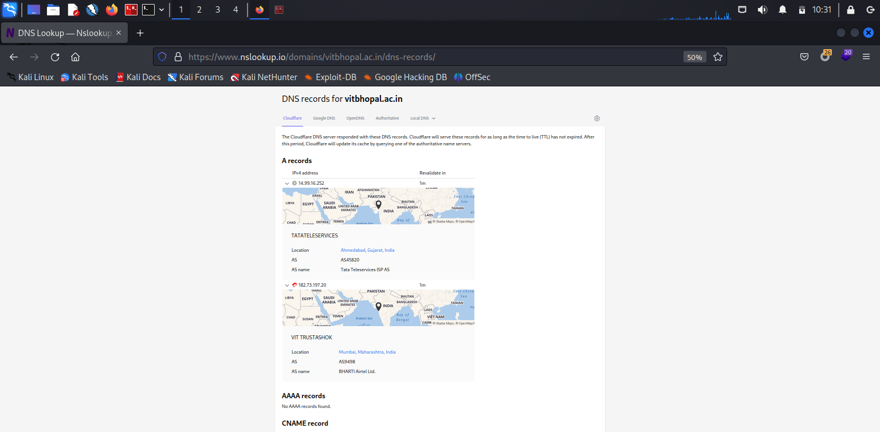

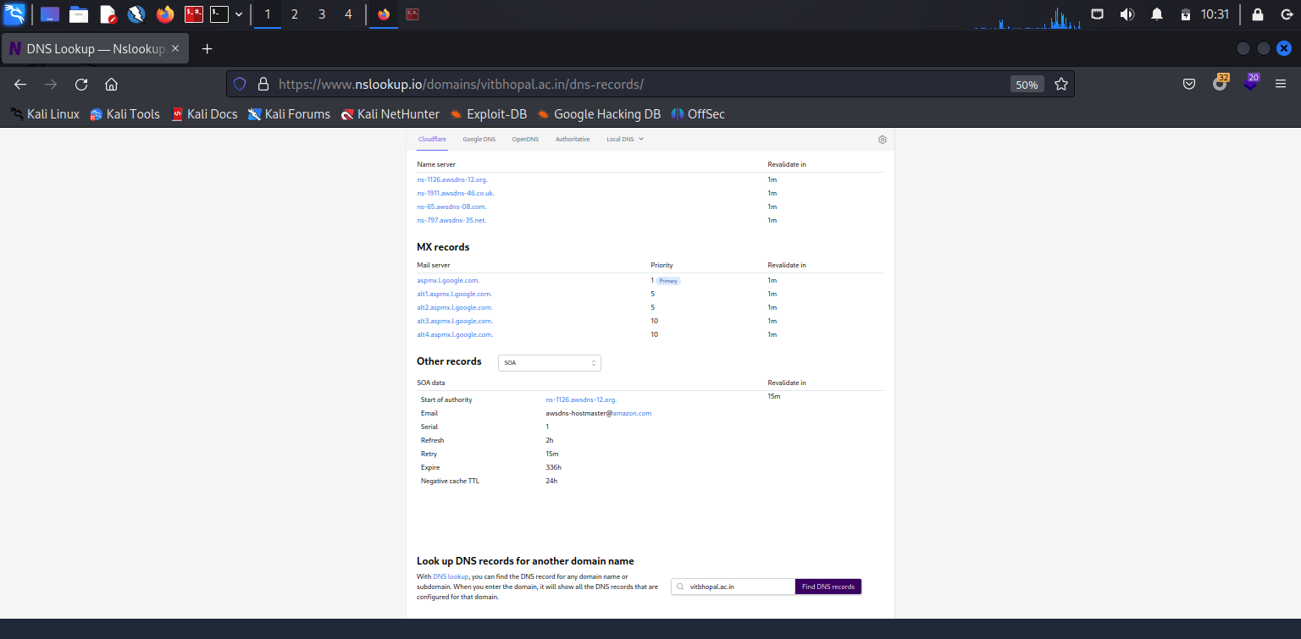

**Nmap scan:**

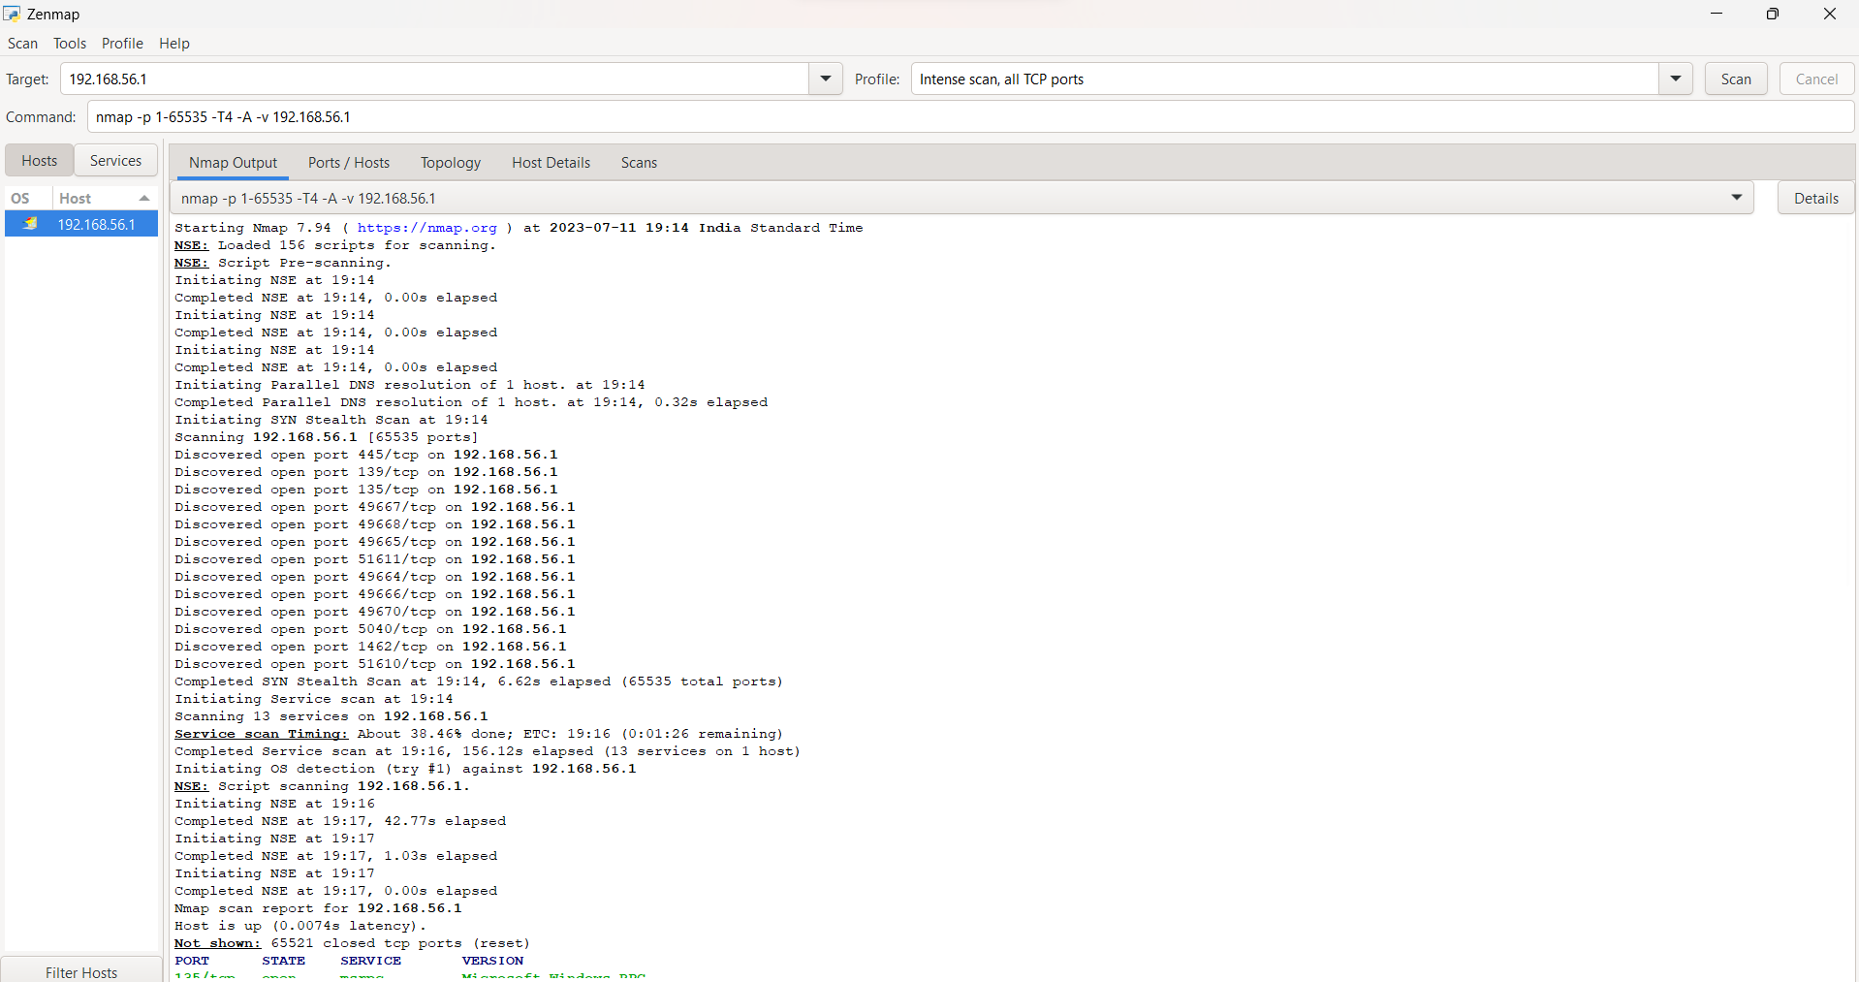

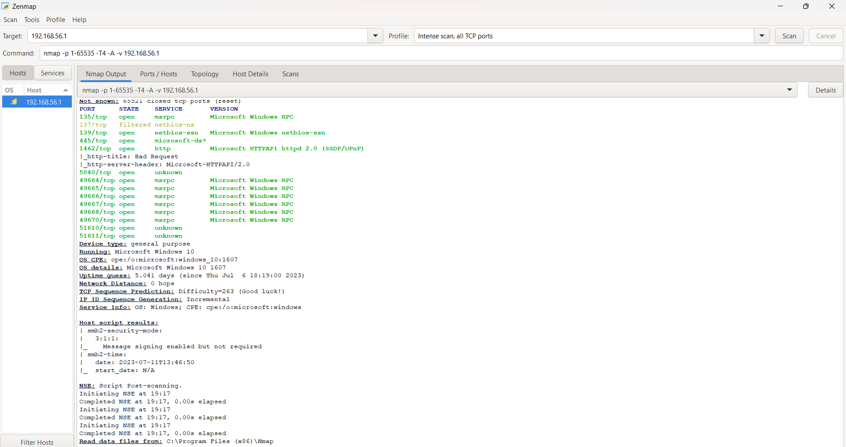

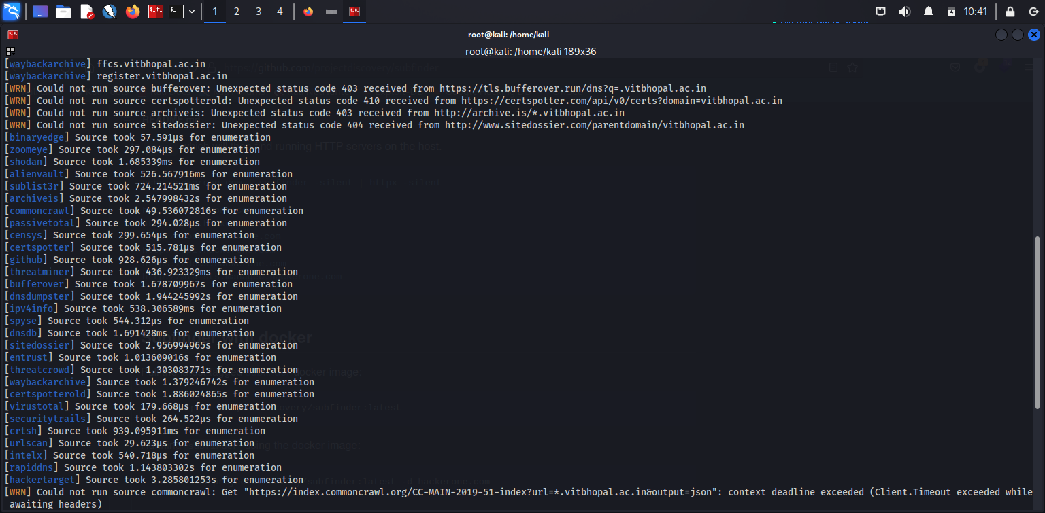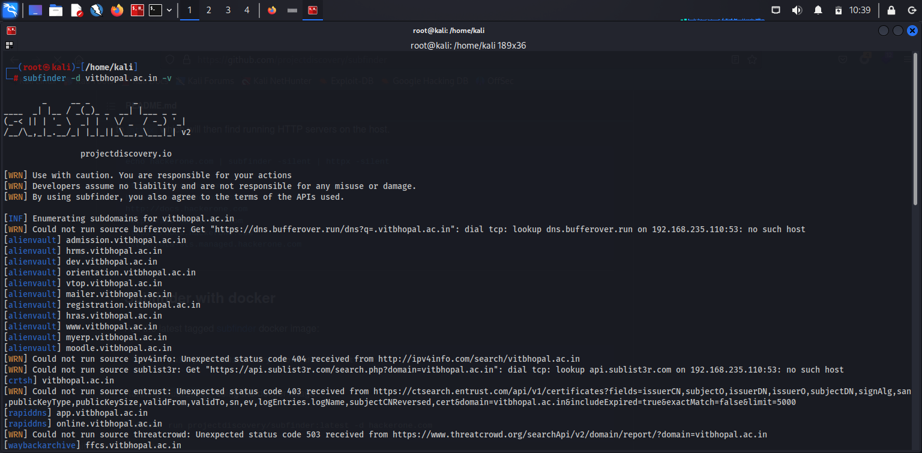**Subdomains:**

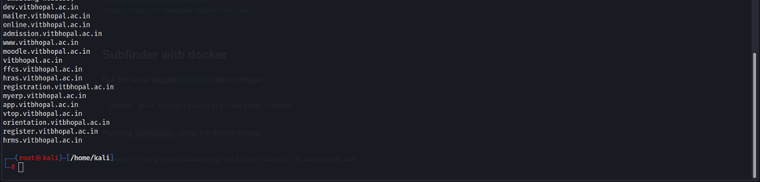

**Wappalyzer:**

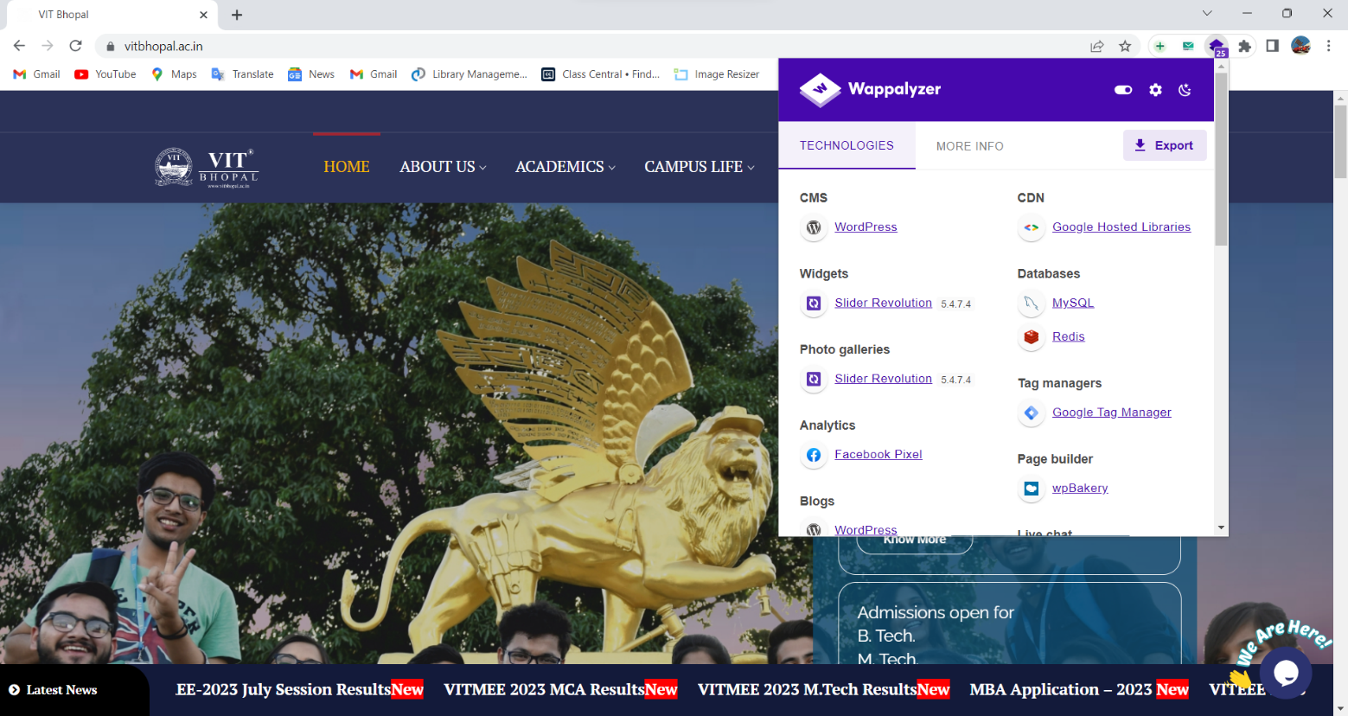

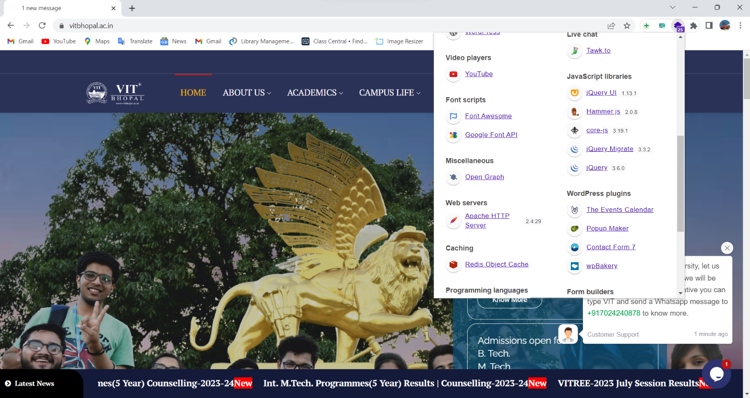

**RECONNAISSANCE AND FOOTPRINTING**

Firstly, we need to find the open ports on our website using nmap commands. Here we have taken our practice website *metasploitable2.*

To begin with, we need to analyse from which port we need to start our exploitation. So we have analysed data of each open port and come to a conclusion of which port to exploit.

**Open ports Information:**

**1. Port 21 (FTP - File Transfer Protocol):**

* FTP is a standard network protocol used for transferring files between a client and a server.
* Port 21 is dedicated to FTP control traffic, which handles commands and responses between the client and server.
* It is commonly used for uploading and downloading files to and from a server.
* FTP can be vulnerable to attacks such as brute-forcing, command injection, or unauthorized access if not properly secured.

**2. Port 22 (SSH - Secure Shell):**

* SSH is a cryptographic network protocol that provides secure remote access to systems over an unsecured network.
* Port 22 is the default port used by SSH for establishing secure shell connections.
* It is commonly used for secure remote administration and file transfers.
* SSH provides strong encryption and authentication mechanisms, making it a more secure alternative to protocols like Telnet.

**3. Port 23 (Telnet):**

* Telnet is an unencrypted network protocol used for remote access to systems.
* Port 23 is the default port used by Telnet for establishing connections.
* Telnet transmits data in plain text, which makes it insecure, as credentials and other sensitive information can be intercepted.
* It is recommended to use SSH instead of Telnet for secure remote access.

**4. Port 25 (SMTP - Simple Mail Transfer Protocol):**

* SMTP is a protocol used for sending and receiving email messages between mail servers.
* Port 25 is the default port used for SMTP traffic.
* It handles the transmission of email messages from the sender's mail server to the recipient's mail server.
* SMTP can be vulnerable to attacks such as email spoofing, relay abuse, or unauthorized access if not properly secured.

**5. Port 3306 (MySQL):**

* MySQL is an open-source relational database management system.
* Port 3306 is the default port used for MySQL database traffic.
* It is used for client-server communication, query execution, and database administration tasks.
* MySQL databases can be targeted for attacks such as SQL injection, unauthorized access, or privilege escalation if not properly secured.

**6. Port 8180:**

* Port 8180 is often used as an alternative HTTP port.
* It can be used for web servers or applications that require a non-standard HTTP port.
* The specific usage or application running on this port may vary depending on the system's configuration.

**7. Port 139 (NetBIOS - Network Basic Input/Output System):**

* NetBIOS is an older networking protocol used for file sharing, print services, and network browsing in Windows systems.
* Port 139 is used for NetBIOS Session Service, which facilitates communication between devices on a network.
* It can be involved in certain types of attacks like NetBIOS enumeration or SMB (Server Message Block) exploitation if not properly secured.

**8. Port 514:**

* Port 514 is commonly associated with the Syslog protocol.
* Syslog is a standard protocol used for logging and collecting system events from network devices and servers.
* It is typically used for centralized logging and analysis of system logs.
* Syslog data can provide valuable insights into the security and operational status of systems.

**9. Port 5432 (PostgreSQL):**

* PostgreSQL is an open-source relational database management system.
* Port 5432 is the default port used for PostgreSQL database traffic.
* It is used for client-server communication, query execution, and database administration tasks.
* PostgreSQL databases can be targeted for attacks such as SQL injection, unauthorized access, or privilege escalation if not properly secured.

We have chosen to proceed with the port exploitation on port 21, 22, 139 and 3306.

**Exploitation:**

# Port 21

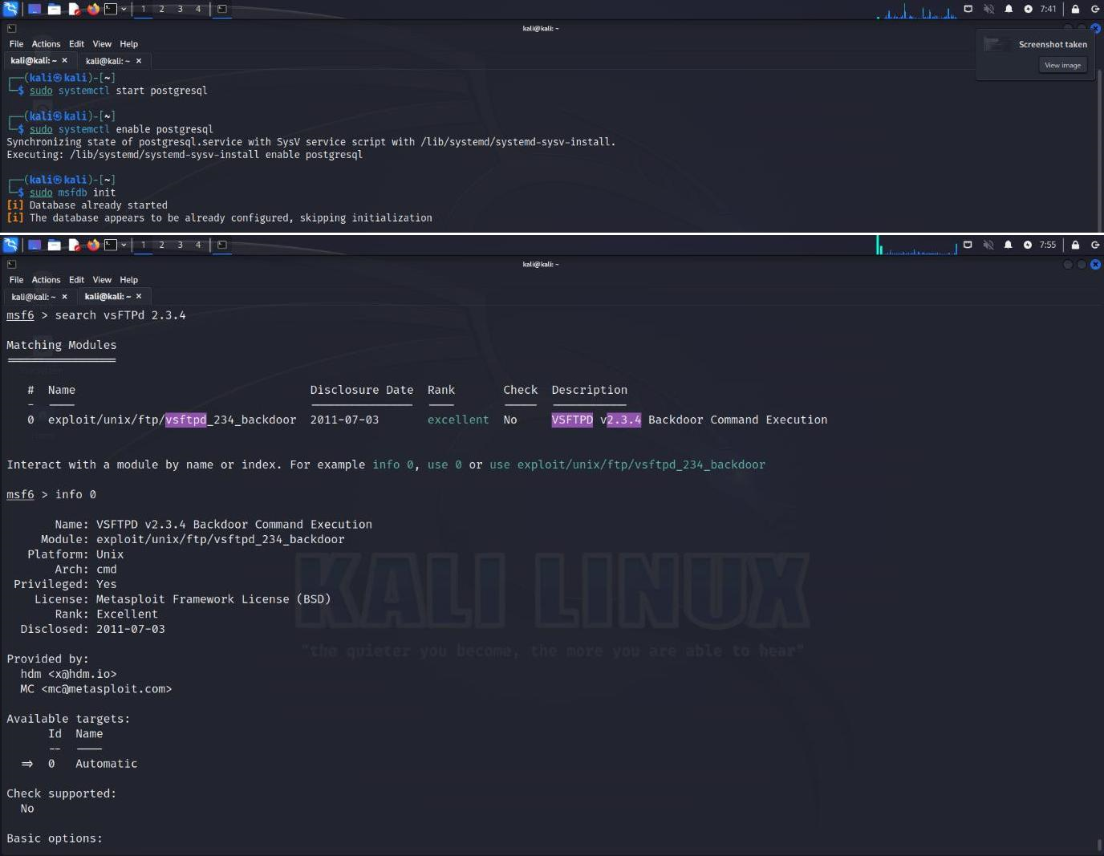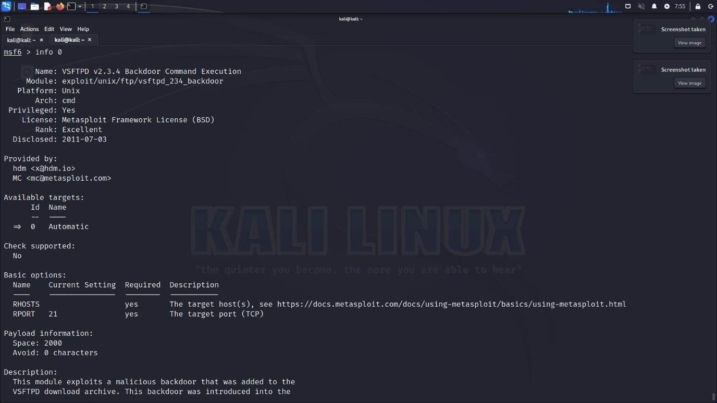

**Port 139**

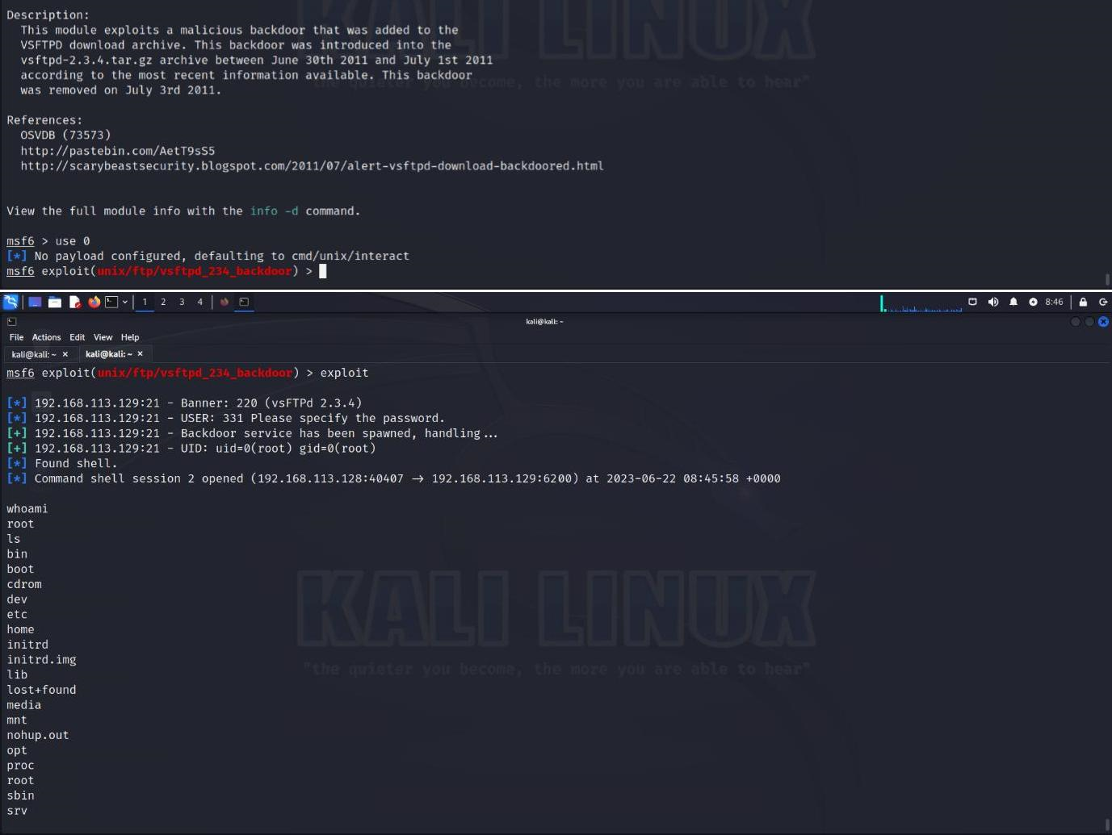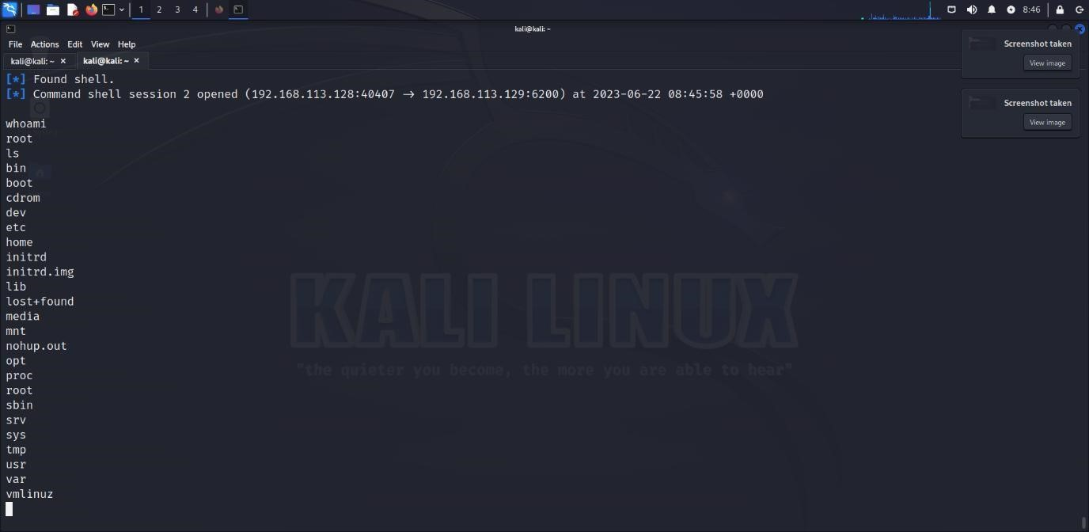

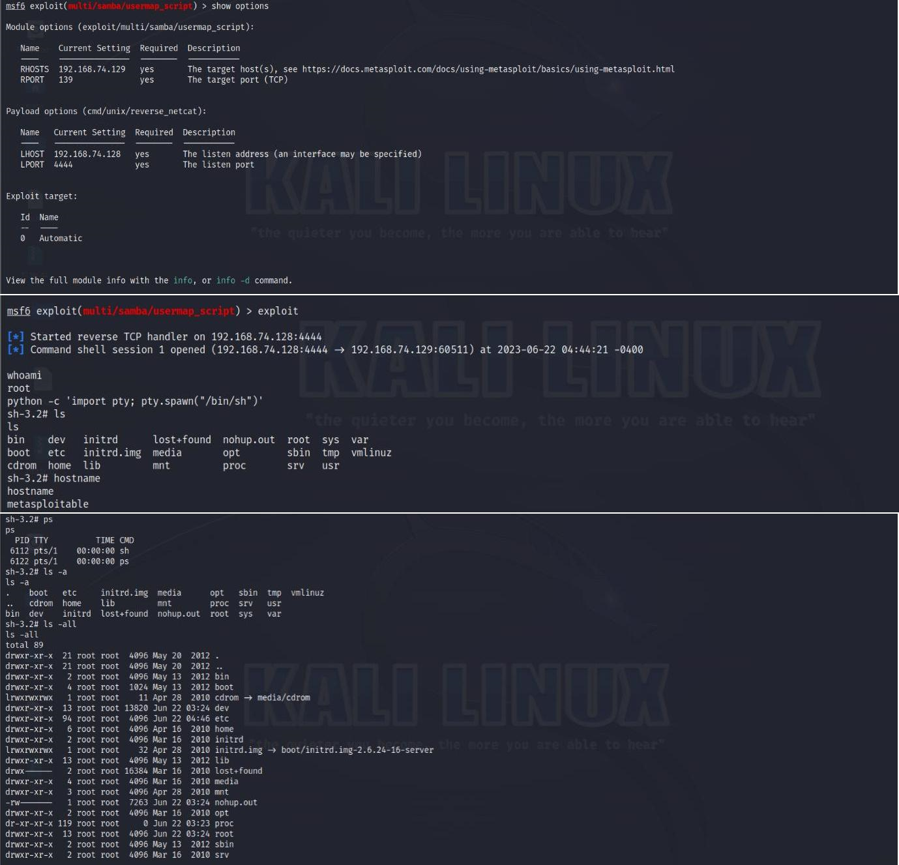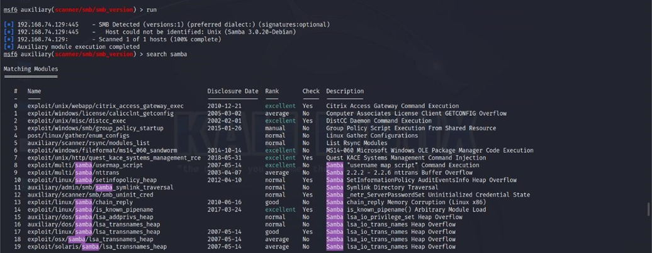

**Port 3306**

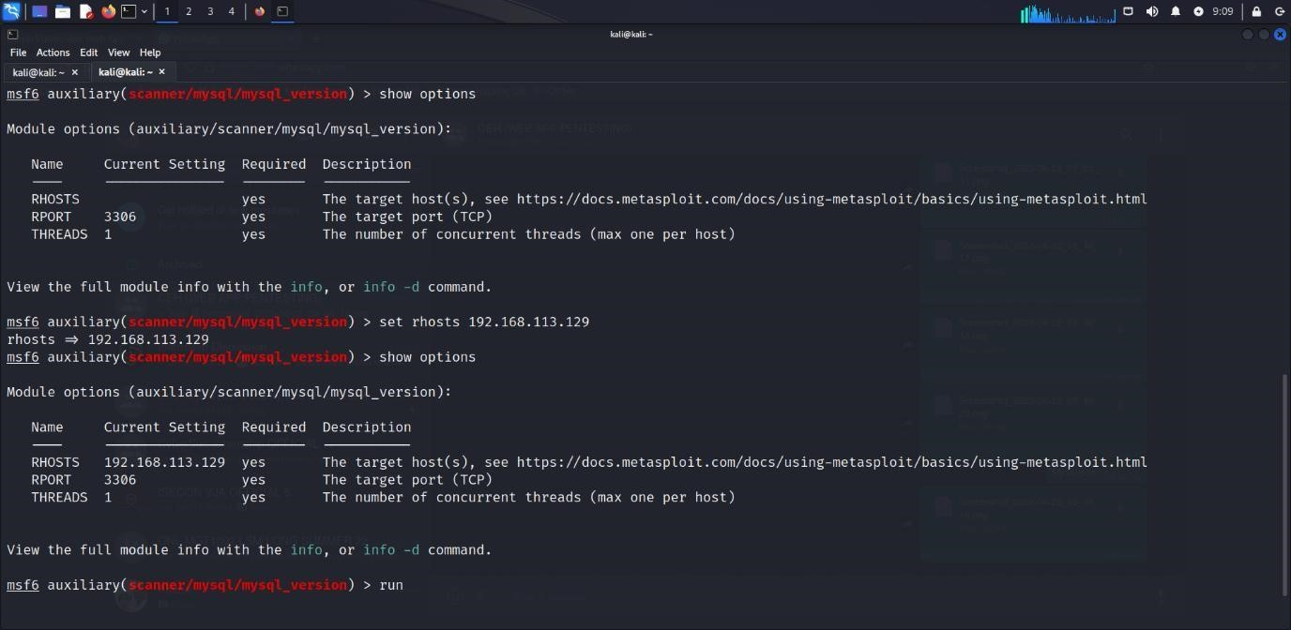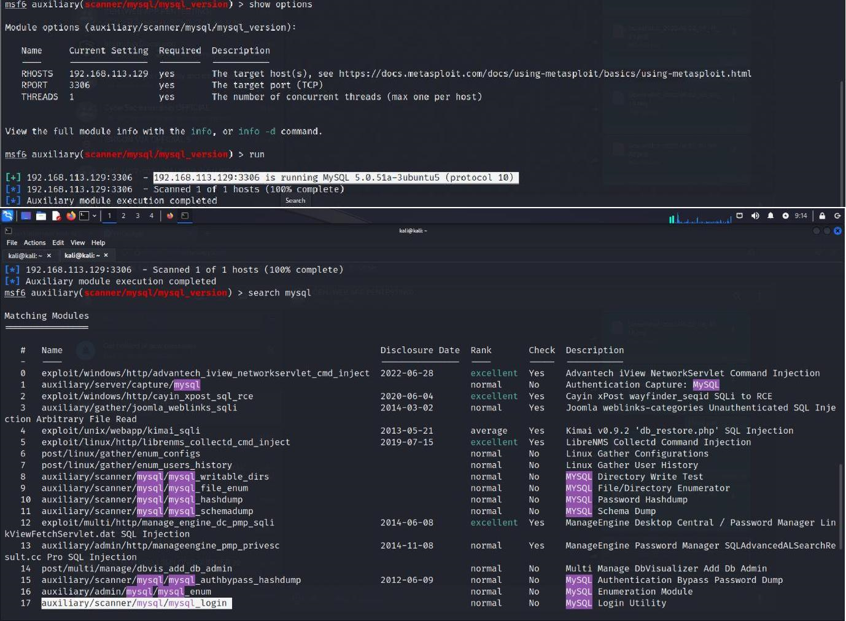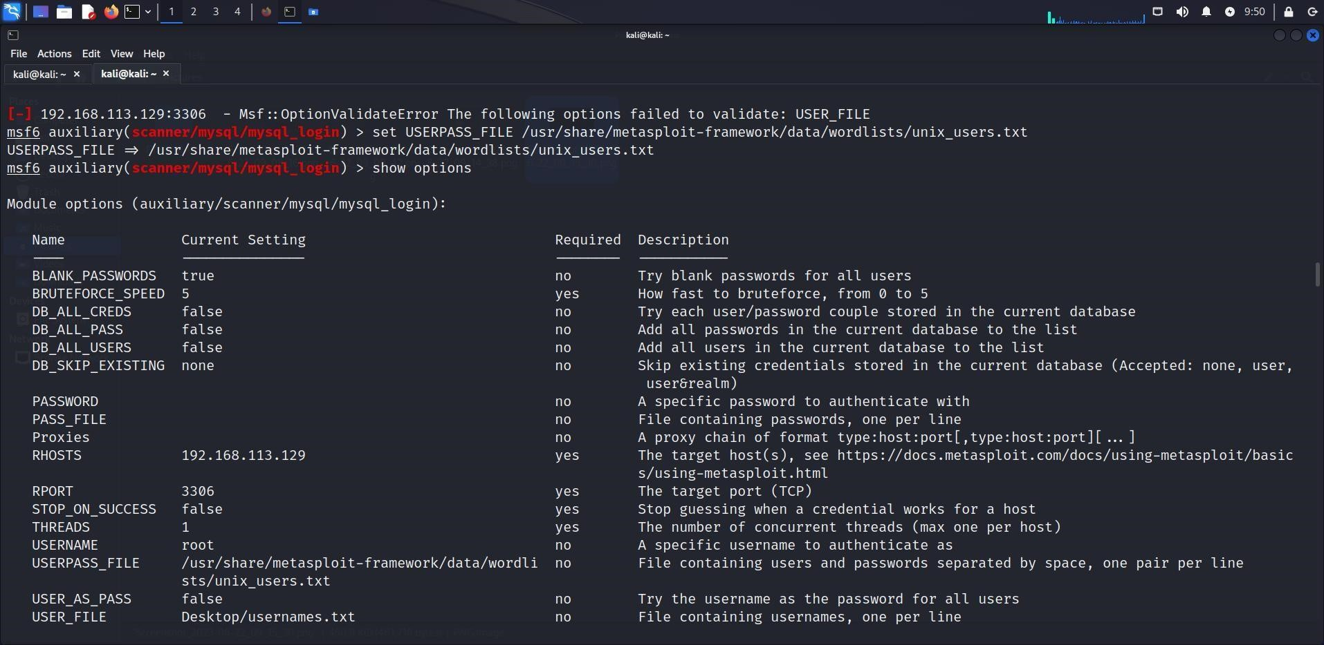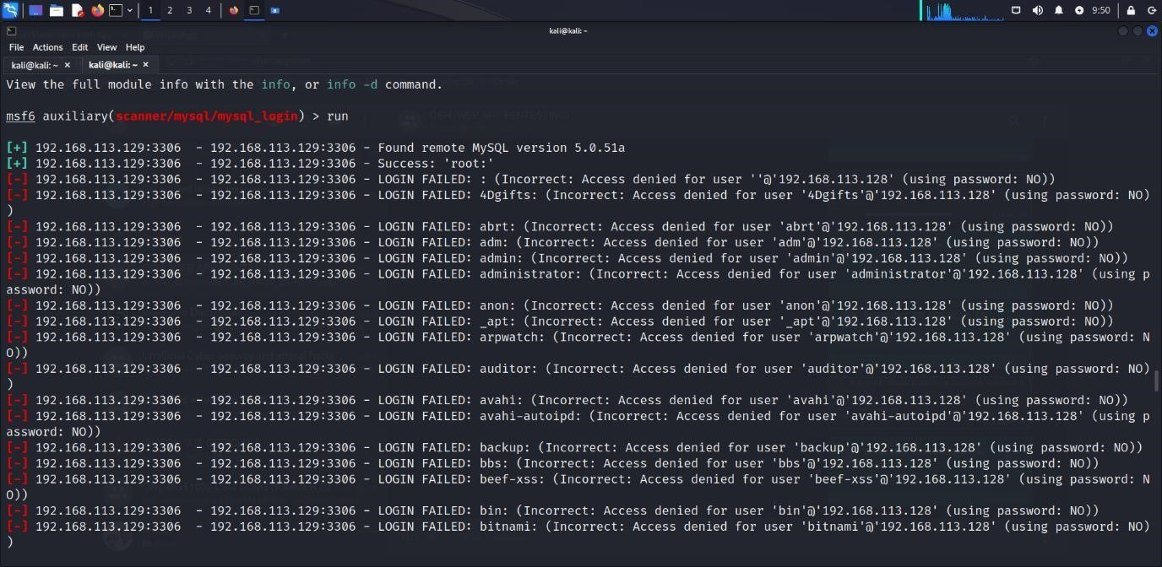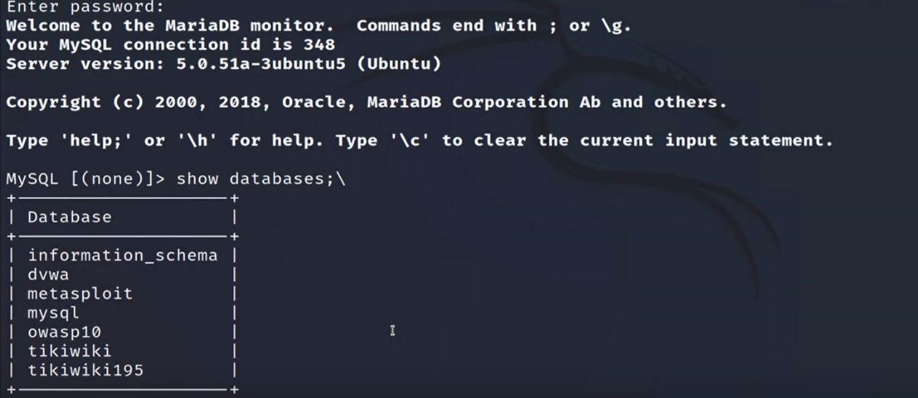

# Port 22

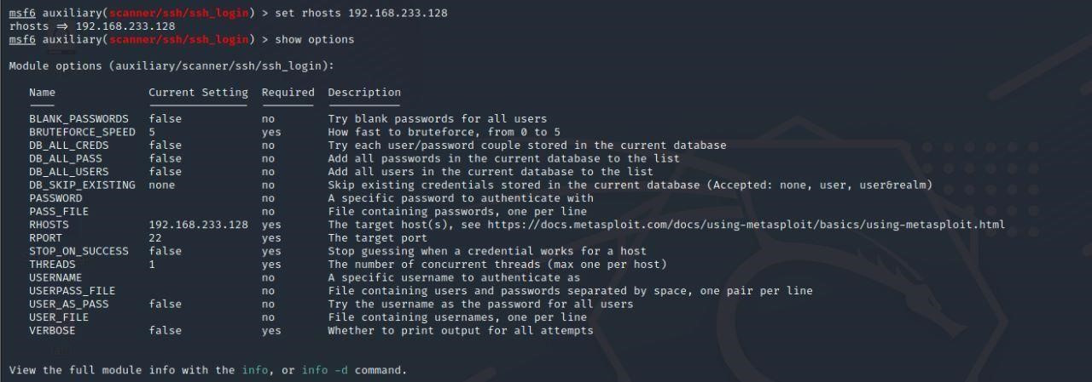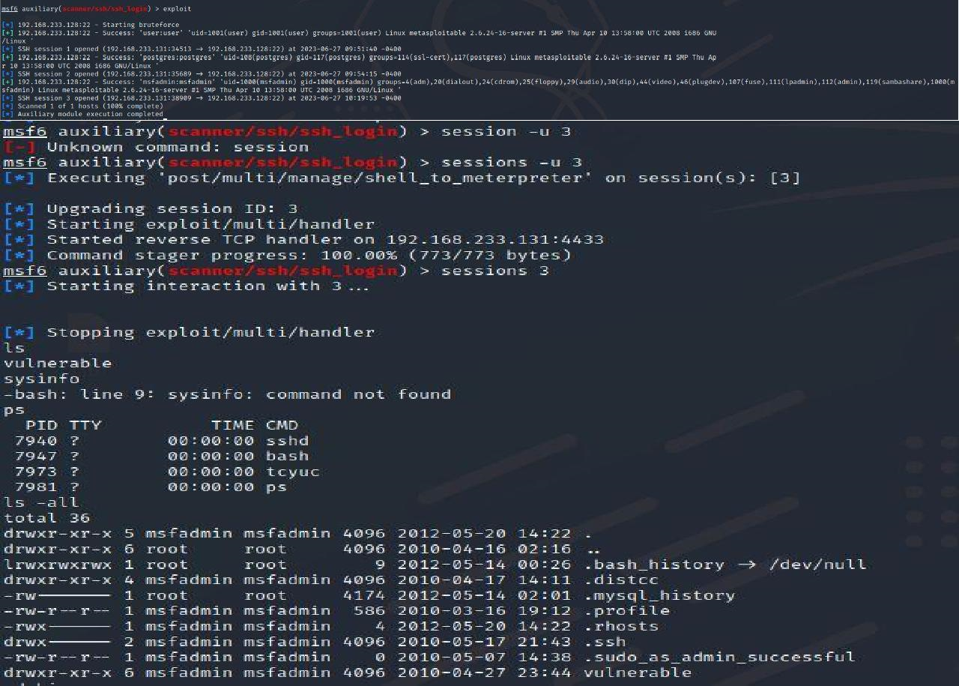

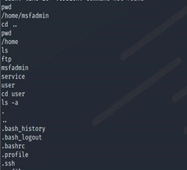

**OWASP Top 10:**

The OWASP Top 10is a list of the ten most critical web application security risks identified by the Open Web Application Security Project (OWASP). These risks represent common vulnerabilities and weaknesses that can be exploited by attackers. The current version of the OWASP Top 10 (as of my knowledge cutoff in September 2021) is:

1. **Injection:**

Unsanitized user inputs that can lead to code injection attacks, such as SQL, OS, or LDAP injection.

1. **Broken Authentication:**

Weaknesses in authentication and session management, including insecure password storage, session hijacking, or weak credential management.

1. **Sensitive Data Exposure:**

Failure to properly protect sensitive information, such as financial data, passwords, or personal identifiable information (PII).

1. **XML External Entities (XXE):**

Improper processing of XML inputs that allows attackers to read internal files or perform remote code execution.

1. **Broken Access Control:**

Inadequate enforcement of authorization controls, leading to unauthorized access and privilege escalation.

1. **Security Misconfigurations:**

Poorly configured security settings, such as default passwords, unpatched software, or exposed sensitive information.

1. **Cross-Site Scripting (XSS):**

Injection of malicious scripts into web pages viewed by users, which can lead to session hijacking or data theft.

1. **Insecure Deserialization:**

Flaws in deserialization processes that can allow remote code execution, injection attacks, or denial of service.

1. **Using Components with Known Vulnerabilities:**

Incorporating outdated or vulnerable software components, libraries, or frameworks into applications.

1. **Insufficient Logging and Monitoring:**

Lack of proper logging and monitoring mechanisms, making it difficult to detect and respond to security incidents effectively.

**Possible Outcome:**

**Injection (OWASP Top 10 #1):**

Hash Disclosure - MD5 Crypt (High)

**Sensitive Data Exposure (OWASP Top 10 #3):**

The scan identified the presence of phpinfo.php, which could potentially expose sensitive information about the server configuration and PHP version.

**Security Misconfigurations (OWASP Top 10 #6):**

` The scan reported outdated Apache version (Apache/2.2.8) and suggested that Apache 2.2.34 is the end-of-life version, indicating a potential security misconfiguration.

* Remote Code Execution - CVE-2012-1823 (High)
* Source Code Disclosure - CVE-2012-1823 (High)
* Directory Browsing (Medium)
* Server Leaks Information via "X-Powered-By" HTTP Response Header Field(s) (Low)
* Server Leaks Version Information via "Server" HTTP Response Header Field (Low)
* Content Security Policy (CSP) Header Not Set (Medium)
* Missing Anti-clickjacking Header (Medium)
* X-Content-Type-Options Header Missing (Low)

**Broken Access Control (OWASP Top 10 #5):**

* Path Traversal (High)

**Cross-Site Scripting (XSS) (OWASP Top 10 #7):**

* Cross Site Scripting (Reflected) (High)
* User Controllable HTML Element Attribute (Potential XSS) (Informational)

**Using Components with Known Vulnerabilities (OWASP Top 10 #9):**

* Vulnerable JS Library (Medium)

**6. Vulnerability scanning and assessment:**

**Target Site:** https://vitbhopal.ac.in

**ZAP Version:** 2.12.0

**Summary of Alerts**

|  |  |
| --- | --- |
| **Risk Level** | **Number of Alerts** |
| High | 1 |
|  | 4 |
| Medium |  |
| Low | 9 |
| Informational | 6 |

**Alerts**

|  |  |  |
| --- | --- | --- |
| **Name** | **Risk Level** | **Number of Instances** |
| hash disclosure - mac osx salted sha-1 | High | 1 |
| Absence of Anti-CSRF Tokens | Medium | 1010 |
| Content Security policy(CSP) Header Not Set | Medium | 596 |
| Missing Anti-clickjacking Header | Medium | 558 |
| Vulnerable JS Library | Medium | 3 |
| Cookie No Http Only Flag | Low | 1304 |
| Cookie Without Secure Flag | Low | 1308 |
| Cookie without SameSite Attribute | Low | 1316 |
| Cross-Domain JavaScript Source File Inclusion | Low | 12 |
| Information Disclosure - Debug Error Messages | Low | 7 |
| Server Leaks Version Information via "Server" HTTP Response Header Field | Low | 4399 |
| Strict-Transport-Security Header Not Set | Low | 4315 |
| Timestamp Disclosure - Unix | Low | 1043 |
| X-Content-Type-Options Header Missing | Low | 3361 |
| Charset Mismatch | Informational | 279 |
| Content-Type Header Missing | Informational | 1 |
| Information Disclosure - Debug Error Messages | Informational | 1594 |
| Modern Web Application | Informational | 415 |
| Re-examine Cache-control Directives | Informational | 374 |
| User Controllable HTML Element Attribute (Potential XSS) | Informational | 789 |

**Alert Detail**

1. **Hash Disclosure - Mac OSX salted SHA-1**

GET https://vitbhopal.ac.in/file/2021/01/Presentation-Image1.jpg

|  |  |
| --- | --- |
| **Alert tags** | * + [OWASP_2021_A04](https://owasp.org/Top10/A04_2021-Insecure_Design/)   + [OWASP_2017_A03](https://owasp.org/www-project-top-ten/2017/A3_2017-Sensitive_Data_Exposure.html) |
| **Alert description** | A hash was disclosed by the web server. - Mac OSX salted SHA-1 |
| **Other info** | DDDDDDDDDDDDDDDDDDDDDDDDDDDDDDDDDDDDDDDDDDDDDDDE |
| **Request** | Request line and header section (463 bytes)  GET https://vitbhopal.ac.in/file/2021/01/Presentation-Image1.jpg HTTP/1.1  Host: vitbhopal.ac.in  User-Agent: Mozilla/5.0 (Windows NT 10.0; Win64; x64; rv:105.0) Gecko/20100101 Firefox/105.0  Pragma: no-cache  Cache-Control: no-cache  Referer: https://vitbhopal.ac.in/cloud/  Cookie: cookiesession1=678A8C31V0234567898901234ABCC95C; quform_session_a9cff1eec9286d8e830d3aabef125d9d=tnhbUTSjveGPYweh2fe4dv1nt3xYSlZdfU6tTNsO; PHPSESSID=q7snd85iir3ijvb4v1oc4kjhb2  Request body (0 bytes) |
| **Response** | Status line and header section (249 bytes)  HTTP/1.1 200 OK  Date: Tue, 11 Jul 2023 16:46:51 GMT  Server: Apache/2.4.29 (Ubuntu)  Last-Modified: Fri, 15 Jan 2021 09:58:07 GMT  ETag: "d0119-5b8ed68bf4c53;5fc81e2e89453"  Accept-Ranges: bytes  Content-Length: 852249  Content-Type: image/jpeg  Response body (852249 bytes) |
| **Evidence** | DDDDDDDDDDDDDDDDDDDDDDDDDDDDDDDDDDDDDDDDDDDDDDDE |
| **Solution** | Ensure that hashes that are used to protect credentials or other resources are not leaked by the web server or database. There is typically no requirement for password hashes to be accessible to the web browser. |

##### **Absence of Anti-CSRF Tokens**

GET <https://vitbhopal.ac.in/>

|  |  |
| --- | --- |
| **Alert tags** | * + [OWASP_2021_A01](https://owasp.org/Top10/A01_2021-Broken_Access_Control/)   + [WSTG-v42-SESS-05](https://owasp.org/www-project-web-security-testing-guide/v42/4-Web_Application_Security_Testing/06-Session_Management_Testing/05-Testing_for_Cross_Site_Request_Forgery)   + [OWASP_2017_A05](https://owasp.org/www-project-top-ten/2017/A5_2017-Broken_Access_Control.html) |
| **Alert description** | No Anti-CSRF tokens were found in a HTML submission form.  A cross-site request forgery is an attack that involves forcing a victim to send an HTTP request to a target destination without their knowledge or intent in order to perform an action as the victim. The underlying cause is application functionality using predictable URL/form actions in a repeatable way. The nature of the attack is that CSRF exploits the trust that a web site has for a user. By contrast, cross-site scripting (XSS) exploits the trust that a user has for a web site. Like XSS, CSRF attacks are not necessarily cross-site, but they can be. Cross-site request forgery is also known as CSRF, XSRF, one-click attack, session riding, confused deputy, and sea surf.  CSRF attacks are effective in a number of situations, including:  * The victim has an active session on the target site.  * The victim is authenticated via HTTP auth on the target site.  * The victim is on the same local network as the target site.  CSRF has primarily been used to perform an action against a target site using the victim's privileges, but recent techniques have been discovered to disclose information by gaining access to the response. The risk of information disclosure is dramatically increased when the target site is vulnerable to XSS, because XSS can be used as a platform for CSRF, allowing the attack to operate within the bounds of the same-origin policy. |
| **Other info** | No known Anti-CSRF token [anticsrf, CSRFToken, __RequestVerificationToken, csrfmiddlewaretoken, authenticity_token, OWASP_CSRFTOKEN, anoncsrf, csrf_token, _csrf, _csrfSecret, __csrf_magic, CSRF, _token, _csrf_token] was found in the following HTML form: [Form 1: "s" ]. |
| **Request** | Request line and header section (235 bytes)  GET https://vitbhopal.ac.in/ HTTP/1.1  Host: vitbhopal.ac.in  User-Agent: Mozilla/5.0 (Windows NT 10.0; Win64; x64; rv:105.0) Gecko/20100101 Firefox/105.0  Pragma: no-cache  Cache-Control: no-cache  Referer: https://vitbhopal.ac.in  Request body (0 bytes) |
| **Response** | Status line and header section (272 bytes)  HTTP/1.1 200 OK  Date: Tue, 11 Jul 2023 16:43:21 GMT  Server: Apache/2.4.29 (Ubuntu)  Last-Modified: Mon, 10 Jul 2023 03:16:12 GMT  ETag: "4fabf-60019679a8840"  Accept-Ranges: bytes  Content-Length: 326335  Vary: Accept-Encoding  Content-Type: text/html; charset=UTF-8  Response body (326335 bytes) |
| **Evidence** | <form name="search_form" method="get" action="https://vitbhopal.ac.in/" class="search_form"> |
| **Solution** | Phase: Architecture and Design  Use a vetted library or framework that does not allow this weakness to occur or provides constructs that make this weakness easier to avoid.  For example, use anti-CSRF packages such as the OWASP CSRFGuard.  Phase: Implementation  Ensure that your application is free of cross-site scripting issues, because most CSRF defenses can be bypassed using attacker-controlled script.  Phase: Architecture and Design  Generate a unique nonce for each form, place the nonce into the form, and verify the nonce upon receipt of the form. Be sure that the nonce is not predictable (CWE-330).  Note that this can be bypassed using XSS.  Identify especially dangerous operations. When the user performs a dangerous operation, send a separate confirmation request to ensure that the user intended to perform that operation.  Note that this can be bypassed using XSS.  Use the ESAPI Session Management control.  This control includes a component for CSRF.  Do not use the GET method for any request that triggers a state change.  Phase: Implementation  Check the HTTP Referer header to see if the request originated from an expected page. This could break legitimate functionality, because users or proxies may have disabled sending the Referer for privacy reasons. |

##### **Content Security Policy (CSP) Header Not Set**

GET https://vitbhopal.ac.in

|  |  |  |
| --- | --- | --- |
| **Alert tags** |  | * [OWASP_2021_A05](https://owasp.org/Top10/A05_2021-Security_Misconfiguration/) * [OWASP_2017_A06](https://owasp.org/www-project-top-ten/2017/A6_2017-Security_Misconfiguration.html) |
| **Alert description** |  | Content Security Policy (CSP) is an added layer of security that helps to detect and mitigate certain types of attacks, including Cross Site Scripting (XSS) and data injection attacks. These attacks are used for everything from data theft to site defacement or distribution of malware. CSP provides a set of standard HTTP headers that allow website owners to declare approved sources of content that browsers should be allowed to load on that page — covered types are JavaScript, CSS, HTML frames, fonts, images and embeddable objects such as Java applets, ActiveX, audio and video files. |
| **Request** |  | Request line and header section (200 bytes)  GET https://vitbhopal.ac.in HTTP/1.1  Host: vitbhopal.ac.in  User-Agent: Mozilla/5.0 (Windows NT 10  .0; Win64; x64; rv:105.0) Gecko/20100101 Firefox/105.0  Pragma: no-cache  Cache-Control: no-cache  Request body (0 bytes) |
| **Response** |  | Status line and header section (387 bytes)  HTTP/1.1 200 OK  Date: Tue, 11 Jul 2023 16:43:20 GMT  Server: Apache/2.4.29 (Ubuntu)  Last-Modified: Mon, 10 Jul 2023 03:16:12 GMT  ETag: "4fabf-60019679a8840"  Accept-Ranges: bytes  Content-Length: 326335  Vary: Accept-Encoding  Content-Type: text/html; charset=UTF-8  Set-Cookie: cookiesession1=678A8C31TUVWXYZABCDEFGIJKLMN47B2;Expires=Wed, 10 Jul 2024 16:43:20 GMT;Path=/;HttpOnly  Response body (326335 bytes) |
| **Solution** |  | Ensure that your web server, application server, load balancer, etc. is configured to set the Content-Security-Policy header. |

##### **Missing Anti-clickjacking Header**

GET https://vitbhopal.ac.in

|  |  |  |
| --- | --- | --- |
| **Alert tags** |  | * + [OWASP_2021_A05](https://owasp.org/Top10/A05_2021-Security_Misconfiguration/)   + [WSTG-v42-CLNT-09](https://owasp.org/www-project-web-security-testing-guide/v42/4-Web_Application_Security_Testing/11-Client-side_Testing/09-Testing_for_Clickjacking)   + [OWASP_2017_A06](https://owasp.org/www-project-top-ten/2017/A6_2017-Security_Misconfiguration.html) |
| **Alert description** |  | The response does not include either Content-Security-Policy with 'frame-ancestors' directive or X-Frame-Options to protect against 'ClickJacking' attacks. |
| **Request** |  | Request line and header section (200 bytes)  GET https://vitbhopal.ac.in HTTP/1.1  Host: vitbhopal.ac.in  User-Agent: Mozilla/5.0 (Windows NT 10.0; Win64; x64; rv:105.0) Gecko/20100101 Firefox/105.0  Pragma: no-cache  Cache-Control: no-cache  Request body (0 bytes) |
| **Response** |  | Status line and header section (387 bytes)  HTTP/1.1 200 OK  Date: Tue, 11 Jul 2023 16:43:20 GMT  Server: Apache/2.4.29 (Ubuntu)  Last-Modified: Mon, 10 Jul 2023 03:16:12 GMT  ETag: "4fabf-60019679a8840"  Accept-Ranges: bytes  Content-Length: 326335  Vary: Accept-Encoding  Content-Type: text/html; charset=UTF-8  Set-Cookie: cookiesession1=678A8C31TUVWXYZABCDEFGIJKLMN47B2;Expires=Wed, 10 Jul 2024 16:43:20 GMT;Path=/;HttpOnly  Response body (326335 bytes) |
| **Parameter** |  | X-Frame-Options |
| **Solution** |  | Modern Web browsers support the Content-Security-Policy and X-Frame-Options HTTP headers. Ensure one of them is set on all web pages returned by your site/app.  If you expect the page to be framed only by pages on your server (e.g. it's part of a FRAMESET) then you'll want to use SAMEORIGIN, otherwise if you never expect the page to be framed, you should use DENY. Alternatively consider implementing Content Security Policy's "frame-ancestors" directive. |

##### **Vulnerable JS Library**

1. GET https://vitbhopal.ac.in/other/js/jquery/ui/core.min.js

|  |  |  |
| --- | --- | --- |
| **Alert tags** |  | * + [OWASP_2017_A09](https://owasp.org/www-project-top-ten/2017/A9_2017-Using_Components_with_Known_Vulnerabilities.html)   + [OWASP_2021_A06](https://owasp.org/Top10/A06_2021-Vulnerable_and_Outdated_Components/)   + [CVE-2022-31160](https://nvd.nist.gov/vuln/detail/CVE-2022-31160) |
| **Alert description** |  | The identified library jquery-ui, version 1.13.1 is vulnerable. |
| **Other info** |  | CVE-2022-31160 |
|  |  | Request line and header section (450 bytes)  GET https://vitbhopal.ac.in/other/js/jquery/ui/core.min.js HTTP/1.1  Host: vitbhopal.ac.in  User-Agent: Mozilla/5.0 (Windows NT 10.0; Win64; x64; rv:105.0) Gecko/20100101 Firefox/105.0  Pragma: no-cache  Cache-Control: no-cache  Referer: https://vitbhopal.ac.in  Cookie: cookiesession1=678A8C31V0234567898901234ABCC95C; quform_session_a9cff1eec9286d8e830d3aabef125d9d=tnhbUTSjveGPYweh2fe4dv1nt3xYSlZdfU6tTNsO; PHPSESSID=q7snd85iir3ijvb4v1oc4kjhb2  Request body (0 bytes) |
| **Response** |  | Status line and header section (282 bytes)  HTTP/1.1 200 OK  Date: Tue, 11 Jul 2023 16:43:46 GMT  Server: Apache/2.4.29 (Ubuntu)  Last-Modified: Wed, 20 Apr 2022 01:59:11 GMT  ETag: "50ea-5dd0c56f01427;5fc81e2e89453"  Accept-Ranges: bytes  Content-Length: 20714  Vary: Accept-Encoding  Content-Type: application/javascript  Response body (20714 bytes) |
| **Evidence** |  | /*! jQuery UI - v1.13.1 |
| **Solution** |  | Please upgrade to the latest version of jquery-ui. |

##### **Server Leaks Version Information via "Server" HTTP Response Header Field**

GET https://vitbhopal.ac.in

|  |  |  |
| --- | --- | --- |
| **Alert tags** |  | * + [OWASP_2021_A05](https://owasp.org/Top10/A05_2021-Security_Misconfiguration/)   + [OWASP_2017_A06](https://owasp.org/www-project-top-ten/2017/A6_2017-Security_Misconfiguration.html)   + [WSTG-v42-INFO-02](https://owasp.org/www-project-web-security-testing-guide/v42/4-Web_Application_Security_Testing/01-Information_Gathering/02-Fingerprint_Web_Server) |
| **Alert description** |  | The web/application server is leaking version information via the "Server" HTTP response header. Access to such information may facilitate attackers identifying other vulnerabilities your web/application server is subject to. |
| **Request** |  | Request line and header section (200 bytes)  GET https://vitbhopal.ac.in HTTP/1.1  Host: vitbhopal.ac.in  User-Agent: Mozilla/5.0 (Windows NT 10.0; Win64; x64; rv:105.0) Gecko/20100101 Firefox/105.0  Pragma: no-cache  Cache-Control: no-cache  Request body (0 bytes) |
| **Response** |  | Status line and header section (387 bytes)  HTTP/1.1 200 OK  Date: Tue, 11 Jul 2023 16:43:20 GMT  Server: Apache/2.4.29 (Ubuntu)  Last-Modified: Mon, 10 Jul 2023 03:16:12 GMT  ETag: "4fabf-60019679a8840"  Accept-Ranges: bytes  Content-Length: 326335  Vary: Accept-Encoding  Content-Type: text/html; charset=UTF-8  Set-Cookie: cookiesession1=678A8C31TUVWXYZABCDEFGIJKLMN47B2;Expires=Wed, 10 Jul 2024 16:43:20 GMT;Path=/;HttpOnly  Response body (326335 bytes) |
| **Evidence** |  | Apache/2.4.29 (Ubuntu) |
| **Solution** |  | Ensure that your web server, application server, load balancer, etc. is configured to suppress the "Server" header or provide generic details. |

##### **Strict-Transport-Security Header Not Set**

GET <https://vitbhopal.ac.in>

|  |  |  |
| --- | --- | --- |
| **Alert tags** |  | * + [OWASP_2021_A05](https://owasp.org/Top10/A05_2021-Security_Misconfiguration/)   + [OWASP_2017_A06](https://owasp.org/www-project-top-ten/2017/A6_2017-Security_Misconfiguration.html) |
| **Alert description** |  | HTTP Strict Transport Security (HSTS) is a web security policy mechanism whereby a web server declares that complying user agents (such as a web browser) are to interact with it using only secure HTTPS connections (i.e. HTTP layered over TLS/SSL). HSTS is an IETF standards track protocol and is specified in RFC 6797. |
|  |  | Request line and header section (200 bytes)  GET https://vitbhopal.ac.in HTTP/1.1  Host: vitbhopal.ac.in  User-Agent: Mozilla/5.0 (Windows NT 10.0; Win64; x64; rv:105.0) Gecko/20100101 Firefox/105.0  Pragma: no-cache  Cache-Control: no-cache  Request body (0 bytes) |
| **Response** |  | Status line and header section (387 bytes)  HTTP/1.1 200 OK  Date: Tue, 11 Jul 2023 16:43:20 GMT  Server: Apache/2.4.29 (Ubuntu)  Last-Modified: Mon, 10 Jul 2023 03:16:12 GMT  ETag: "4fabf-60019679a8840"  Accept-Ranges: bytes  Content-Length: 326335  Vary: Accept-Encoding  Content-Type: text/html; charset=UTF-8  Set-Cookie: cookiesession1=678A8C31TUVWXYZABCDEFGIJKLMN47B2;Expires=Wed, 10 Jul 2024 16:43:20 GMT;Path=/;HttpOnly  Response body (326335 bytes) |
| **Solution** |  | Ensure that your web server, application server, load balancer, etc. is configured to enforce Strict-Transport-Security. |

##### **Cookie No HttpOnly Flag**

GET https://vitbhopal.ac.in/ticker_news/int-m-sc-programmes5-year-counselling-2023-24new/

|  |  |
| --- | --- |
| **Alert tags** | * + [OWASP_2021_A05](https://owasp.org/Top10/A05_2021-Security_Misconfiguration/)   + [WSTG-v42-SESS-02](https://owasp.org/www-project-web-security-testing-guide/v42/4-Web_Application_Security_Testing/06-Session_Management_Testing/02-Testing_for_Cookies_Attributes)   + [OWASP_2017_A06](https://owasp.org/www-project-top-ten/2017/A6_2017-Security_Misconfiguration.html) |
| **Alert description** | A cookie has been set without the HttpOnly flag, which means that the cookie can be accessed by JavaScript. If a malicious script can be run on this page then the cookie will be accessible and can be transmitted to another site. If this is a session cookie then session hijacking may be possible. |
| **Request** | Request line and header section (443 bytes)  GET https://vitbhopal.ac.in/ticker_news/int-m-sc-programmes5-year-counselling-2023-24new/ HTTP/1.1  Host: vitbhopal.ac.in  User-Agent: Mozilla/5.0 (Windows NT 10.0; Win64; x64; rv:105.0) Gecko/20100101 Firefox/105.0  Pragma: no-cache  Cache-Control: no-cache  Referer: https://vitbhopal.ac.in  Cookie: quform_session_a9cff1eec9286d8e830d3aabef125d9d=Cvd49TMO09VG9wcTF0cAt7UoY8eNGGYMsNfZ4t0A; cookiesession1=678A8C31V0234567898901234ABCC95C  Request body (0 bytes) |
| **Response** | Status line and header section (428 bytes)  HTTP/1.1 301 Moved Permanently  Date: Tue, 11 Jul 2023 16:43:30 GMT  Server: Apache/2.4.29 (Ubuntu)  Set-Cookie: PHPSESSID=ial2qeenvqtq6a7cnhvl74s64n; path=/  Expires: Thu, 19 Nov 1981 08:52:00 GMT  Cache-Control: no-store, no-cache, must-revalidate  Pragma: no-cache  X-Redirect-By: WordPress  Location: https://admissionresults.vit.ac.in/integratedmsccounselling  Content-Length: 26  Content-Type: text/html; charset=UTF-8  Response body (26 bytes) |
| **Parameter** | PHPSESSID |
| **Evidence** | Set-Cookie: PHPSESSID |
| **Solution** | Ensure that the HttpOnly flag is set for all cookies. |

##### **Cookie Without Secure Flag**

GET https://vitbhopal.ac.in

|  |  |  |
| --- | --- | --- |
| **Alert tags** |  | * + [OWASP_2021_A05](https://owasp.org/Top10/A05_2021-Security_Misconfiguration/)   + [WSTG-v42-SESS-02](https://owasp.org/www-project-web-security-testing-guide/v42/4-Web_Application_Security_Testing/06-Session_Management_Testing/02-Testing_for_Cookies_Attributes)   + [OWASP_2017_A06](https://owasp.org/www-project-top-ten/2017/A6_2017-Security_Misconfiguration.html) |
| **Alert description** |  | A cookie has been set without the secure flag, which means that the cookie can be accessed via unencrypted connections. |
| **Request** |  | Request line and header section (200 bytes)  GET https://vitbhopal.ac.in HTTP/1.1  Host: vitbhopal.ac.in  User-Agent: Mozilla/5.0 (Windows NT 10.0; Win64; x64; rv:105.0) Gecko/20100101 Firefox/105.0  Pragma: no-cache  Cache-Control: no-cache  Request body (0 bytes) |
| **Response** |  | Status line and header section (387 bytes)  HTTP/1.1 200 OK  Date: Tue, 11 Jul 2023 16:43:20 GMT  Server: Apache/2.4.29 (Ubuntu)  Last-Modified: Mon, 10 Jul 2023 03:16:12 GMT  ETag: "4fabf-60019679a8840"  Accept-Ranges: bytes  Content-Length: 326335  Vary: Accept-Encoding  Content-Type: text/html; charset=UTF-8  Set-Cookie: cookiesession1=678A8C31TUVWXYZABCDEFGIJKLMN47B2;Expires=Wed, 10 Jul 2024 16:43:20 GMT;Path=/;HttpOnly  Response body (326335 bytes) |
| **Parameter** |  | cookiesession1 |
| **Evidence** |  | Set-Cookie: cookiesession1 |
| **Solution** |  | Whenever a cookie contains sensitive information or is a session token, then it should always be passed using an encrypted channel. Ensure that the secure flag is set for cookies containing such sensitive information. |

##### **Cookie without SameSite Attribute**

GET https://vitbhopal.ac.in

|  |  |  |
| --- | --- | --- |
| **Alert tags** |  | * + [OWASP_2021_A01](https://owasp.org/Top10/A01_2021-Broken_Access_Control/)   + [WSTG-v42-SESS-02](https://owasp.org/www-project-web-security-testing-guide/v42/4-Web_Application_Security_Testing/06-Session_Management_Testing/02-Testing_for_Cookies_Attributes)   + [OWASP_2017_A05](https://owasp.org/www-project-top-ten/2017/A5_2017-Broken_Access_Control.html) |
| **Alert description** |  | A cookie has been set without the SameSite attribute, which means that the cookie can be sent as a result of a 'cross-site' request. The SameSite attribute is an effective counter measure to cross-site request forgery, cross-site script inclusion, and timing attacks. |
| **Request** |  | Request line and header section (200 bytes)  GET https://vitbhopal.ac.in HTTP/1.1  Host: vitbhopal.ac.in  User-Agent: Mozilla/5.0 (Windows NT 10.0; Win64; x64; rv:105.0) Gecko/20100101 Firefox/105.0  Pragma: no-cache  Cache-Control: no-cache  Request body (0 bytes) |
| **Response** |  | Status line and header section (387 bytes)  HTTP/1.1 200 OK  Date: Tue, 11 Jul 2023 16:43:20 GMT  Server: Apache/2.4.29 (Ubuntu)  Last-Modified: Mon, 10 Jul 2023 03:16:12 GMT  ETag: "4fabf-60019679a8840"  Accept-Ranges: bytes  Content-Length: 326335  Vary: Accept-Encoding  Content-Type: text/html; charset=UTF-8  Set-Cookie: cookiesession1=678A8C31TUVWXYZABCDEFGIJKLMN47B2;Expires=Wed, 10 Jul 2024 16:43:20 GMT;Path=/;HttpOnly  Response body (326335 bytes) |
| **Parameter** |  | cookiesession1 |
| **Evidence** |  | Set-Cookie: cookiesession1 |
| **Solution** |  | Ensure that the SameSite attribute is set to either 'lax' or ideally 'strict' for all cookies. |

##### **Cross-Domain JavaScript Source File Inclusion**

GET <https://vitbhopal.ac.in/indore/>

|  |  |
| --- | --- |
| **Alert tags** | * + [OWASP_2021_A08](https://owasp.org/Top10/A08_2021-Software_and_Data_Integrity_Failures/) |
| **Alert description** | The page includes one or more script files from a third-party domain. |
| **Request** | Request line and header section (427 bytes)  GET https://vitbhopal.ac.in/indore/ HTTP/1.1  Host: vitbhopal.ac.in  User-Agent: Mozilla/5.0 (Windows NT 10.0; Win64; x64; rv:105.0) Gecko/20100101 Firefox/105.0  Pragma: no-cache  Cache-Control: no-cache  Referer: https://vitbhopal.ac.in  Cookie: quform_session_a9cff1eec9286d8e830d3aabef125d9d=Cvd49TMO09VG9wcTF0cAt7UoY8eNGGYMsNfZ4t0A; cookiesession1=678A8C31V0234567898901234ABCC95C; PHPSESSID=l7cs8l84l5jko8imk6rbabffng  Request body (0 bytes) |
| **Response** | Status line and header section (286 bytes)  HTTP/1.1 200 OK  Date: Tue, 11 Jul 2023 16:43:35 GMT  Server: Apache/2.4.29 (Ubuntu)  Last-Modified: Fri, 07 Jul 2023 10:39:10 GMT  ETag: "1d5e5-5ffe33e3c4301;5fc81e2e89453"  Accept-Ranges: bytes  Content-Length: 120293  Vary: Accept-Encoding  Content-Type: text/html; charset=UTF-8  Response body (120293 bytes) |
| **Parameter** | https://www.google.com/recaptcha/api.js?onload=QuformRecaptchaLoaded&render=explicit&hl |
| **Evidence** | <script type='text/javascript' src='https://www.google.com/recaptcha/api.js?onload=QuformRecaptchaLoaded&#038;render=explicit&#038;hl' id='quform-recaptcha-js'></script> |
| **Solution** | Ensure JavaScript source files are loaded from only trusted sources, and the sources can't be controlled by end users of the application. |

##### **Information Disclosure - Debug Error Messages**

GET <https://vitbhopal.ac.in/infrastructure/>

|  |  |
| --- | --- |
| **Alert tags** | * + [OWASP_2021_A01](https://owasp.org/Top10/A01_2021-Broken_Access_Control/)   + [WSTG-v42-ERRH-01](https://owasp.org/www-project-web-security-testing-guide/v42/4-Web_Application_Security_Testing/08-Testing_for_Error_Handling/01-Testing_For_Improper_Error_Handling)   + [OWASP_2017_A03](https://owasp.org/www-project-top-ten/2017/A3_2017-Sensitive_Data_Exposure.html) |
| **Alert description** | The response appeared to contain common error messages returned by platforms such as ASP.NET, and Web-servers such as IIS and Apache. You can configure the list of common debug messages. |
| **Request** | Request line and header section (250 bytes)  GET https://vitbhopal.ac.in/infrastructure/ HTTP/1.1  Host: vitbhopal.ac.in  User-Agent: Mozilla/5.0 (Windows NT 10.0; Win64; x64; rv:105.0) Gecko/20100101 Firefox/105.0  Pragma: no-cache  Cache-Control: no-cache  Referer: https://vitbhopal.ac.in  Request body (0 bytes) |
| **Response** | Status line and header section (401 bytes)  HTTP/1.1 200 OK  Date: Tue, 11 Jul 2023 16:43:22 GMT  Server: Apache/2.4.29 (Ubuntu)  Last-Modified: Fri, 07 Jul 2023 08:59:01 GMT  ETag: "1eb29-5ffe1d812ff18;5fc81e2e89453"  Accept-Ranges: bytes  Content-Length: 125737  Vary: Accept-Encoding  Content-Type: text/html; charset=UTF-8  Set-Cookie: cookiesession1=678A8C31BDEFGHIJKLMNOPQRSTUV3EBF;Expires=Wed, 10 Jul 2024 16:43:22 GMT;Path=/;HttpOnly  Response body (125737 bytes) |
| **Evidence** | under construction |
| **Solution** | Disable debugging messages before pushing to production. |

##### **X-Content-Type-Options Header Missing**

GET https://vitbhopal.ac.in

|  |  |
| --- | --- |
| **Alert tags** | * + [OWASP_2021_A05](https://owasp.org/Top10/A05_2021-Security_Misconfiguration/)   + [OWASP_2017_A06](https://owasp.org/www-project-top-ten/2017/A6_2017-Security_Misconfiguration.html) |
| **Alert description** | The Anti-MIME-Sniffing header X-Content-Type-Options was not set to 'nosniff'. This allows older versions of Internet Explorer and Chrome to perform MIME-sniffing on the response body, potentially causing the response body to be interpreted and displayed as a content type other than the declared content type. Current (early 2014) and legacy versions of Firefox will use the declared content type (if one is set), rather than performing MIME-sniffing. |
| **Other info** | This issue still applies to error type pages (401, 403, 500, etc.) as those pages are often still affected by injection issues, in which case there is still concern for browsers sniffing pages away from their actual content type.  At "High" threshold this scan rule will not alert on client or server error responses. |
| **Request** | Request line and header section (200 bytes)  GET https://vitbhopal.ac.in HTTP/1.1  Host: vitbhopal.ac.in  User-Agent: Mozilla/5.0 (Windows NT 10.0; Win64; x64; rv:105.0) Gecko/20100101 Firefox/105.0  Pragma: no-cache  Cache-Control: no-cache  Request body (0 bytes) |
| **Response** | Status line and header section (387 bytes)  HTTP/1.1 200 OK  Date: Tue, 11 Jul 2023 16:43:20 GMT  Server: Apache/2.4.29 (Ubuntu)  Last-Modified: Mon, 10 Jul 2023 03:16:12 GMT  ETag: "4fabf-60019679a8840"  Accept-Ranges: bytes  Content-Length: 326335  Vary: Accept-Encoding  Content-Type: text/html; charset=UTF-8  Set-Cookie: cookiesession1=678A8C31TUVWXYZABCDEFGIJKLMN47B2;Expires=Wed, 10 Jul 2024 16:43:20 GMT;Path=/;HttpOnly  Response body (326335 bytes) |
| **Parameter** | X-Content-Type-Options |
| **Solution** | Ensure that the application/web server sets the Content-Type header appropriately, and that it sets the X-Content-Type-Options header to 'nosniff' for all web pages.  If possible, ensure that the end user uses a standards-compliant and modern web browser that does not perform MIME-sniffing at all, or that can be directed by the web application/web server to not perform MIME-sniffing. |

##### **Timestamp Disclosure - Unix**

GET https://vitbhopal.ac.in

|  |  |
| --- | --- |
| **Alert tags** | * + [OWASP_2021_A01](https://owasp.org/Top10/A01_2021-Broken_Access_Control/)   + [OWASP_2017_A03](https://owasp.org/www-project-top-ten/2017/A3_2017-Sensitive_Data_Exposure.html) |
| **Alert description** | A timestamp was disclosed by the application/web server - Unix |
| **Other info** | 1650988847, which evaluates to: 2022-04-26 12:00:47 |
| **Request** | Request line and header section (200 bytes)  GET https://vitbhopal.ac.in HTTP/1.1  Host: vitbhopal.ac.in  User-Agent: Mozilla/5.0 (Windows NT 10.0; Win64; x64; rv:105.0) Gecko/20100101 Firefox/105.0  Pragma: no-cache  Cache-Control: no-cache  Request body (0 bytes) |
| **Response** | Status line and header section (387 bytes)  HTTP/1.1 200 OK  Date: Tue, 11 Jul 2023 16:43:20 GMT  Server: Apache/2.4.29 (Ubuntu)  Last-Modified: Mon, 10 Jul 2023 03:16:12 GMT  ETag: "4fabf-60019679a8840"  Accept-Ranges: bytes  Content-Length: 326335  Vary: Accept-Encoding  Content-Type: text/html; charset=UTF-8  Set-Cookie: cookiesession1=678A8C31TUVWXYZABCDEFGIJKLMN47B2;Expires=Wed, 10 Jul 2024 16:43:20 GMT;Path=/;HttpOnly  Response body (326335 bytes) |
| **Evidence** | 1650988847 |
| **Solution** | Manually confirm that the timestamp data is not sensitive, and that the data cannot be aggregated to disclose exploitable patterns. |

##### **Content-Type Header Missing**

GET https://vitbhopal.ac.in/ext/js_composer/assets/lib/bower/font-awesome/fonts/fontawesome-webfont.woff2?v=4.7.0

|  |  |
| --- | --- |
| **Alert tags** | * + [OWASP_2021_A05](https://owasp.org/Top10/A05_2021-Security_Misconfiguration/)   + [OWASP_2017_A06](https://owasp.org/www-project-top-ten/2017/A6_2017-Security_Misconfiguration.html) |
| **Alert description** | The Content-Type header was either missing or empty. |
| **Request** | Request line and header section (729 bytes)  GET https://vitbhopal.ac.in/ext/js_composer/assets/lib/bower/font-awesome/fonts/fontawesome-webfont.woff2?v=4.7.0 HTTP/1.1  Host: vitbhopal.ac.in  User-Agent: Mozilla/5.0 (X11; Linux x86_64; rv:102.0) Gecko/20100101 Firefox/102.0  Accept: application/font-woff2;q=1.0,application/font-woff;q=0.9,*/*;q=0.8  Accept-Language: en-US,en;q=0.5  Connection: keep-alive  Referer: https://vitbhopal.ac.in/ext/js_composer/assets/lib/bower/font-awesome/css/font-awesome.min.css  Cookie: cookiesession1=678A8C31901234ACDEFGHIJKLMNO6962; PHPSESSID=rq82cucoveiccnc1umoai6hbfe; quform_session_a9cff1eec9286d8e830d3aabef125d9d=QThSYYHBBK8mPag6Ba4CKH8BUEwKDuqJMJES3jUs  Sec-Fetch-Dest: font  Sec-Fetch-Mode: cors  Sec-Fetch-Site: same-origin  Request body (0 bytes) |
| **Response** | Status line and header section (277 bytes)  HTTP/1.1 200 OK  Date: Tue, 11 Jul 2023 17:09:15 GMT  Server: Apache/2.4.29 (Ubuntu)  Last-Modified: Mon, 23 Dec 2019 07:33:34 GMT  ETag: "12d68-59a5a0b7c8f80;5fc81e2e89453"  Accept-Ranges: bytes  Content-Length: 77160  Keep-Alive: timeout=5, max=92  Connection: Keep-Alive  Response body (77160 bytes) |
| **Solution** | Ensure each page is setting the specific and appropriate content-type value for the content being delivered. |

##### **Modern Web Application**

GET https://vitbhopal.ac.in

|  |  |  |
| --- | --- | --- |
| **Alert tags** |  |  |
| **Alert description** |  | The application appears to be a modern web application. If you need to explore it automatically then the Ajax Spider may well be more effective than the standard one. |
| **Other info** |  | Links have been found that do not have traditional href attributes, which is an indication that this is a modern web application. |
| **Request** |  | Request line and header section (200 bytes)  GET https://vitbhopal.ac.in HTTP/1.1  Host: vitbhopal.ac.in  User-Agent: Mozilla/5.0 (Windows NT 10.0; Win64; x64; rv:105.0) Gecko/20100101 Firefox/105.0  Pragma: no-cache  Cache-Control: no-cache  Request body (0 bytes) |
| **Response** |  | Status line and header section (387 bytes)  HTTP/1.1 200 OK  Date: Tue, 11 Jul 2023 16:43:20 GMT  Server: Apache/2.4.29 (Ubuntu)  Last-Modified: Mon, 10 Jul 2023 03:16:12 GMT  ETag: "4fabf-60019679a8840"  Accept-Ranges: bytes  Content-Length: 326335  Vary: Accept-Encoding  Content-Type: text/html; charset=UTF-8  Set-Cookie: cookiesession1=678A8C31TUVWXYZABCDEFGIJKLMN47B2;Expires=Wed, 10 Jul 2024 16:43:20 GMT;Path=/;HttpOnly  Response body (326335 bytes) |
| **Evidence** |  | <a href="#">info@vitbhopal.ac.in</a> |
| **Solution** |  | This is an informational alert and so no changes are required. |

##### **Charset Mismatch**

GET https://vitbhopal.ac.in/wp-json/oembed/1.0/embed?format=xml&url=https%3A%2F%2Fvitbhopal.ac.in%2F

|  |  |  |
| --- | --- | --- |
| **Alert tags** |  |  |
| **Alert description** |  | This check identifies responses where the HTTP Content-Type header declares a charset different from the charset defined by the body of the HTML or XML. When there's a charset mismatch between the HTTP header and content body Web browsers can be forced into an undesirable content-sniffing mode to determine the content's correct character set.  An attacker could manipulate content on the page to be interpreted in an encoding of their choice. For example, if an attacker can control content at the beginning of the page, they could inject script using UTF-7 encoded text and manipulate some browsers into interpreting that text. |
| **Other info** |  | There was a charset mismatch between the HTTP Header and the XML encoding declaration: [UTF-8] and [null] do not match. |
| **Request** |  | Request line and header section (492 bytes)  GET https://vitbhopal.ac.in/wp-json/oembed/1.0/embed?format=xml&url=https%3A%2F%2Fvitbhopal.ac.in%2F HTTP/1.1  Host: vitbhopal.ac.in  User-Agent: Mozilla/5.0 (Windows NT 10.0; Win64; x64; rv:105.0) Gecko/20100101 Firefox/105.0  Pragma: no-cache  Cache-Control: no-cache  Referer: https://vitbhopal.ac.in  Cookie: cookiesession1=678A8C31V0234567898901234ABCC95C; quform_session_a9cff1eec9286d8e830d3aabef125d9d=tnhbUTSjveGPYweh2fe4dv1nt3xYSlZdfU6tTNsO; PHPSESSID=q7snd85iir3ijvb4v1oc4kjhb2  Request body (0 bytes) |
| **Response** |  | Status line and header section (654 bytes)  HTTP/1.1 200 OK  Date: Tue, 11 Jul 2023 16:43:42 GMT  Server: Apache/2.4.29 (Ubuntu)  Set-Cookie: PHPSESSID=q7snd85iir3ijvb4v1oc4kjhb2; path=/  Expires: Thu, 19 Nov 1981 08:52:00 GMT  Cache-Control: no-store, no-cache, must-revalidate  Pragma: no-cache  X-Robots-Tag: noindex  Link: <https://vitbhopal.ac.in/wp-json/>; rel="https://api.w.org/"  X-Content-Type-Options: nosniff  Access-Control-Expose-Headers: X-WP-Total, X-WP-TotalPages, Link  Access-Control-Allow-Headers: Authorization, X-WP-Nonce, Content-Disposition, Content-MD5, Content-Type |
|  |  | Allow: GET  Vary: Origin,Accept-Encoding  Content-Length: 2519  Content-Type: text/xml; charset=UTF-8  Response body (2519 bytes) |
| **Solution** |  | Force UTF-8 for all text content in both the HTTP header and meta tags in HTML or encoding declarations in XML. |

##### **Information Disclosure - Suspicious Comments**

GET https://vitbhopal.ac.in

|  |  |  |
| --- | --- | --- |
| **Alert tags** |  | * + [OWASP_2021_A01](https://owasp.org/Top10/A01_2021-Broken_Access_Control/)   + [WSTG-v42-INFO-05](https://owasp.org/www-project-web-security-testing-guide/v42/4-Web_Application_Security_Testing/01-Information_Gathering/05-Review_Webpage_Content_for_Information_Leakage)   + [OWASP_2017_A03](https://owasp.org/www-project-top-ten/2017/A3_2017-Sensitive_Data_Exposure.html) |
| **Alert description** |  | The response appears to contain suspicious comments which may help an attacker. Note: Matches made within script blocks or files are against the entire content not only comments. |
| **Other info** |  | The following pattern was used: \bADMINISTRATOR\b and was detected in the element starting with: "<script type='text/javascript' id='bravepop_front_js-js-extra'>  /* <![CDATA[ */  var bravepop_global = {"loggedin":"false","isadm", see evidence field for the suspicious comment/snippet. |
| **Request** |  | Request line and header section (200 bytes)  GET https://vitbhopal.ac.in HTTP/1.1  Host: vitbhopal.ac.in  User-Agent: Mozilla/5.0 (Windows NT 10.0; Win64; x64; rv:105.0) Gecko/20100101 Firefox/105.0  Pragma: no-cache  Cache-Control: no-cache  Request body (0 bytes) |
| **Response** |  | Status line and header section (387 bytes)  HTTP/1.1 200 OK  Date: Tue, 11 Jul 2023 16:43:20 GMT  Server: Apache/2.4.29 (Ubuntu)  Last-Modified: Mon, 10 Jul 2023 03:16:12 GMT  ETag: "4fabf-60019679a8840" |
| Accept-Ranges: bytes  Content-Length: 326335  Vary: Accept-Encoding  Content-Type: text/html; charset=UTF-8  Set-Cookie: cookiesession1=678A8C31TUVWXYZABCDEFGIJKLMN47B2;Expires=Wed, 10 Jul 2024 16:43:20 GMT;Path=/;HttpOnly  Response body (326335 bytes) |
| **Evidence** |  | administrator |
| **Solution** |  | Remove all comments that return information that may help an attacker and fix any underlying problems they refer to. |

##### **Re-examine Cache-control Directives**

GET https://vitbhopal.ac.in

|  |  |
| --- | --- |
| **Alert tags** | * + [WSTG-v42-ATHN-06](https://owasp.org/www-project-web-security-testing-guide/v42/4-Web_Application_Security_Testing/04-Authentication_Testing/06-Testing_for_Browser_Cache_Weaknesses) |
| **Alert description** | The cache-control header has not been set properly or is missing, allowing the browser and proxies to cache content. For static assets like css, js, or image files this might be intended, however, the resources should be reviewed to ensure that no sensitive content will be cached. |
| **Request** | Request line and header section (200 bytes)  GET https://vitbhopal.ac.in HTTP/1.1  Host: vitbhopal.ac.in  User-Agent: Mozilla/5.0 (Windows NT 10.0; Win64; x64; rv:105.0) Gecko/20100101 Firefox/105.0  Pragma: no-cache  Cache-Control: no-cache  Request body (0 bytes) |
| **Response** | Status line and header section (387 bytes)  HTTP/1.1 200 OK  Date: Tue, 11 Jul 2023 16:43:20 GMT  Server: Apache/2.4.29 (Ubuntu)  Last-Modified: Mon, 10 Jul 2023 03:16:12 GMT  ETag: "4fabf-60019679a8840"  Accept-Ranges: bytes  Content-Length: 326335  Vary: Accept-Encoding  Content-Type: text/html; charset=UTF-8  Set-Cookie: cookiesession1=678A8C31TUVWXYZABCDEFGIJKLMN47B2;Expires=Wed, 10 Jul 2024 16:43:20 GMT;Path=/;HttpOnly  Response body (326335 bytes) |
| **Parameter** | Cache-Control |
| **Solution** | For secure content, ensure the cache-control HTTP header is set with "no-cache, no-store, must-revalidate". If an asset should be cached consider setting the directives "public, max-age, immutable". |

##### **User Controllable HTML Element Attribute (Potential XSS)**

POST https://vitbhopal.ac.in/student-ambassador-program/

|  |  |  |
| --- | --- | --- |
| **Alert tags** |  | * + [OWASP_2021_A03](https://owasp.org/Top10/A03_2021-Injection/)   + [OWASP_2017_A01](https://owasp.org/www-project-top-ten/2017/A1_2017-Injection.html) |
| **Alert description** |  | This check looks at user-supplied input in query string parameters and POST data to identify where certain HTML attribute values might be controlled. This provides hot-spot detection for XSS (cross-site scripting) that will require further review by a security analyst to determine exploitability. |
| **Other info** |  | User-controlled HTML attribute values were found. Try injecting special characters to see if XSS might be possible. The page at the following URL:  https://vitbhopal.ac.in/student-ambassador-program/  appears to include user input in:  a(n) [meta] tag [content] attribute  The user input found was:  quform_current_page_id=1  The user-controlled value was:  width=device-width, initial-scale=1, maximum-scale=1 |
| **Request** |  | Request line and header section (546 bytes)  POST https://vitbhopal.ac.in/student-ambassador-program/ HTTP/1.1  Host: vitbhopal.ac.in  User-Agent: Mozilla/5.0 (Windows NT 10.0; Win64; x64; rv:105.0) Gecko/20100101 Firefox/105.0 |
|  |  | Pragma: no-cache  Cache-Control: no-cache  Content-Type: application/x-www-form-urlencoded  Referer: https://vitbhopal.ac.in/student-ambassador-program/  Content-Length: 452  Cookie: cookiesession1=678A8C31V0234567898901234ABCC95C; quform_session_a9cff1eec9286d8e830d3aabef125d9d=tnhbUTSjveGPYweh2fe4dv1nt3xYSlZdfU6tTNsO; PHPSESSID=q7snd85iir3ijvb4v1oc4kjhb2  Request body (452 bytes)  quform_submit=submit&quform_form_id=2&quform_form_uid=7a06ab&quform_count=3&form_url=https%3A%2F%2Fvitbhopal.ac.in%2Fstudent-ambassador-program%2F&referring_url=https%3A%2F%2Fvitbhopal.ac.in%2F&post_id=9351&post_title=Student+Ambassador+Program%40VIT+Bhopal&quform_current_page_id=1&quform_csrf_token=i0Ml1wMEPbE1QfxnJJvVGUx2wW8hhOcOih626yTm&quform_2_3=ZAP&quform_2_4=foo-bar%40example.com&quform_2_5=ZAP&quform_2_6=Call&quform_2_7=Hindi&quform_2_0=ZAP |
| **Response** |  | Status line and header section (699 bytes)  HTTP/1.1 200 OK  Date: Tue, 11 Jul 2023 16:45:11 GMT  Server: Apache/2.4.29 (Ubuntu)  Set-Cookie: PHPSESSID=q7snd85iir3ijvb4v1oc4kjhb2; path=/  Expires: Thu, 19 Nov 1981 08:52:00 GMT  Cache-Control: no-store, no-cache, must-revalidate  Pragma: no-cache  Link: <https://vitbhopal.ac.in/wp-json/>; rel="https://api.w.org/"  Link: <https://vitbhopal.ac.in/wp-json/wp/v2/pages/9351>; rel="alternate"; type="application/json"  Link: <https://vitbhopal.ac.in/?p=9351>; rel=shortlink  X-TEC-API-VERSION: v1  X-TEC-API-ROOT: https://vitbhopal.ac.in/wp-json/tribe/events/v1/  X-TEC-API-ORIGIN: https://vitbhopal.ac.in  Vary: Accept-Encoding  Content-Type: text/html; charset=UTF-8  content-length: 109432  Response body (109432 bytes) |
| **Parameter** |  | quform_current_page_id |
| **Solution** |  | Validate all input and sanitize output it before writing to any HTML attributes. |

**7. ADVANTAGES & DISADVANTAGES:**

This project on web application pentesting offers several advantages, including:

* Enhanced Security: The primary advantage of web application pentesting is improved security. By identifying vulnerabilities, weaknesses, and potential attack vectors in web applications, pentesting helps organizations address these issues before they can be exploited by malicious actors. This proactive approach significantly reduces the risk of security breaches, data leaks, and unauthorized access.
* Risk Mitigation: Web application pentesting helps organizations identify and mitigate risks associated with their web applications. By identifying vulnerabilities and providing recommendations for remediation, pentesting allows organizations to prioritize and address potential risks effectively. This reduces the likelihood of financial loss, reputational damage, and regulatory non-compliance.
* Compliance with Standards and Regulations: Many industries have specific regulations and standards that require organizations to conduct regular security assessments, including web application pentesting. By performing pentesting, organizations can demonstrate compliance with these requirements, ensuring that they meet the necessary security standards and avoid penalties or legal consequences.
* Proactive Detection of Vulnerabilities: Pentesting allows organizations to proactively detect and address vulnerabilities in their web applications. It goes beyond automated vulnerability scanning by employing manual techniques and human expertise to identify complex vulnerabilities that automated tools may miss. This proactive approach helps prevent potential security incidents and reduces the need for reactive incident response measures.
* Validation of Security Controls: Pentesting provides an opportunity to validate the effectiveness of implemented security controls. It helps organizations assess if security measures, such as authentication mechanisms, access controls, and encryption, are working as intended and effectively protecting the application against potential attacks. This validation ensures that security controls are properly configured and provides insights for necessary adjustments or improvements.
* Awareness and Education: The project on web application pentesting can raise awareness among developers, system administrators, and other stakeholders about the importance of secure coding practices and the potential risks associated with web applications. It promotes a security-focused mindset and fosters a culture of proactive security measures within the organization.
* Continuous Improvement: Pentesting is not a one-time activity but an iterative process. By conducting regular pentesting assessments, organizations can continuously improve the security of their web applications. The findings and recommendations from each pentesting cycle can be used to drive improvements in development practices, secure coding techniques, and overall security posture.
* Customer Confidence and Trust: Demonstrating a commitment to regular web application pentesting and ensuring the security of customer data can enhance customer confidence and trust. Customers are more likely to trust organizations that prioritize security and take proactive measures to protect their information. This can lead to increased customer satisfaction, loyalty, and a positive brand reputation.

Overall, the project on web application pentesting offers numerous advantages that contribute to a more secure and resilient web application environment. It helps organizations proactively identify and mitigate vulnerabilities, comply with regulations, validate security controls, raise awareness, and continuously improve their security practices.

While the project on web application pentesting offers significant benefits, it is important to consider potential disadvantages or challenges that may arise. Here are some possible disadvantages:

* Time and Resource Intensive: Web application pentesting can be a timeconsuming and resource-intensive process. It requires skilled professionals to conduct thorough assessments, analyze findings, and generate comprehensive reports. The project may require significant investment in terms of time, expertise, and financial resources.
* Limited Scope and Coverage: Pentesting focuses on specific web applications or systems within an organization's infrastructure. Due to time constraints or budget limitations, it may not be possible to test all web applications comprehensively. As a result, some vulnerabilities or risks may go undetected, leaving potential entry points for attackers.
* False Sense of Security: The project's findings may give organizations a false sense of security, assuming that their web applications are fully secure after conducting pentesting. While pentesting is an important security measure, it cannot guarantee complete security. New vulnerabilities may emerge, and attackers may employ novel techniques that were not tested during the project.
* Disruption of Services: Pentesting activities may disrupt the normal operation of web applications or systems being tested. The testing process can sometimes cause temporary service interruptions, resulting in potential inconvenience for users or business operations. Proper planning and coordination with stakeholders are necessary to minimize such disruptions.
* Skill and Expertise Requirements: Effective web application pentesting requires skilled professionals with expertise in various areas, including web application security, network infrastructure, and coding practices. Acquiring and retaining such talent may pose challenges, especially for organizations with limited resources or in highly competitive job markets.
* Legal and Ethical Considerations: Conducting web application pentesting involves interacting with systems and networks, which may raise legal and ethical concerns if not properly authorized or performed within a controlled environment. Organizations must ensure they have proper permissions, adhere to ethical guidelines, and comply with applicable laws and regulations.
* Follow-up and Remediation Efforts: Identifying vulnerabilities is just the first step; addressing and remediating those vulnerabilities is equally important. The project may require additional resources and efforts to prioritize and remediate the identified vulnerabilities effectively. Timely remediation is crucial to ensure the identified risks are mitigated promptly.
* Dynamic Nature of Web Applications: Web applications are dynamic and constantly evolving. New features, updates, and changes in technology may introduce new vulnerabilities that were not present during the initial pentesting project. Regular follow-up assessments are necessary to keep up with the evolving security landscape.

Despite these potential disadvantages, web application pentesting remains a crucial component of a robust security program. By understanding and addressing these challenges, organizations can maximize the benefits of the project while mitigating potential drawbacks.

**8. CONCLUSION:**

In conclusion, the project on web application pentesting is a vital undertaking for organizations aiming to enhance the security of their web applications. Through a systematic and proactive approach, the project helps identify vulnerabilities, assess risks, and implement appropriate countermeasures. By conducting thorough assessments and analyses, organizations can gain valuable insights into the security posture of their web applications, enabling them to take proactive steps to mitigate potential risks.

The project's advantages include improved security, risk mitigation, compliance with standards, proactive vulnerability detection, validation of security controls, increased awareness, and continuous improvement. These benefits contribute to a more secure and resilient web application environment, fostering customer confidence and trust.

However, it is important to consider the project's potential disadvantages, such as time and resource intensiveness, limited scope and coverage, false sense of security, disruption of services, skill and expertise requirements, legal and ethical considerations, and the need for follow-up and remediation efforts. Addressing these challenges ensures that the project's outcomes are effectively leveraged and integrated into the organization's overall security strategy.

Overall, the project on web application pentesting plays a crucial role in identifying and mitigating vulnerabilities, enhancing security practices, and minimizing the risk of security breaches and data compromises. By implementing the project's findings and recommendations, organizations can bolster their defense against potential cyber threats and maintain a robust security posture for their web applications.

**9. FUTURE SCOPE**

The future scope of the project on web application pentesting is promising, given the evolving landscape of technology and cyber security. Here are some potential areas of future development and expansion for the project:

* Advanced Testing Techniques: As attackers develop new techniques and exploit emerging vulnerabilities, there is a need for advanced testing techniques in web application pentesting. This includes exploring techniques such as machine learning and artificial intelligence to enhance automated scanning, anomaly detection, and behavior analysis for identifying complex vulnerabilities.
* Mobile Application Pentesting: With the increasing use of mobile applications, the project can be extended to include the pentesting of mobile apps. This involves assessing the security of mobile apps across different platforms and identifying vulnerabilities specific to mobile environments.
* Cloud-Based Application Pentesting: As organizations migrate their applications to cloud platforms, there is a growing need to address the unique security challenges associated with cloud-based applications. The project can explore methodologies and tools for pentesting cloud-based applications, including assessing the security of cloud configurations and APIs.
* Internet of Things (IoT) Security: The proliferation of IoT devices introduces new challenges in terms of security and privacy. The project can expand to include pentesting of web applications that interact with IoT devices, focusing on identifying vulnerabilities in the communication protocols, firmware, and application interfaces.
* Continuous Monitoring and Threat Intelligence: Building on the project's findings, future developments can focus on continuous monitoring and threat intelligence for web applications. This includes leveraging security information and event management (SIEM) systems, threat intelligence feeds, and anomaly detection mechanisms to provide ongoing monitoring and early detection of potential security threats.
* Automation and Orchestration: The project can explore ways to automate and orchestrate web application pentesting processes, allowing for faster and more efficient testing cycles. This includes integrating automated scanning tools, creating custom scripts, and developing frameworks for streamlined and standardized pentesting procedures.
* Security Metrics and Reporting: Enhancing the project's reporting capabilities by developing comprehensive security metrics and visualizations can provide stakeholders

with a clear understanding of the web application's security posture. This includes developing key performance indicators (KPIs) and risk indicators that can be used to measure and communicate the effectiveness of security measures.

* Collaboration and Knowledge Sharing: Encouraging collaboration and knowledge sharing within the security community can be a future focus for the project. This can involve establishing platforms for sharing pentesting methodologies, tools, and best practices, fostering a community of security professionals to exchange insights and experiences.

By exploring these future areas, the project on web application pentesting can stay aligned with emerging technologies, evolving threats, and industry best practices, ultimately enhancing the security of web applications and helping organizations proactively address potential vulnerabilities and risks.

**10.REFERENCE**

1. McGraw, G. (2006). Software Security: Building Security In, Adison Wesley Professional.
2. “Nmap – Free Security Scanner for Network Explorer, <http://nmap.org/>,
3. K. Nirmal, B. Janet And R. Kumar, "Web Application Vulnerabilities - The Hacker's Treasure," 2018 International Conference On Inventive Research In Computing Applications (Icirca), Coimbatore, India, 2018
4. <https://simplysecure.blog/2017/07/05/five-phases-ofpenetration-testing>
5. Baykara, M. Investigation and comparison of web application vulnerabilities test tools. Int. J. Comput. Sci. Mob. Comput. (IJCSMC) 2018, 7, 197–212.
6. https://sdi.ai/blog/advantages-and-disadvantages-of-penetration-testing/
7. K. A. Sedek, N. Osman, M. N. Osman, and H. K. Jusoff, “Developing a Secure Web Application Using OWASP Guidelines,” Comput. Inf. Sci., 2009, doi: 10.5539/cis.v2n4p137.
8. R. Revo, G. Made, A. Sasmita, I. P. Agus, and E. Pratama, “Testing for Information Gathering Using OWASP Testing Guide v4 (Case Study : Udayana University SIMAK-NG Application),” J. Ilm. Teknol. dan Komput., vol. 1, no. 1, 2020
9. A. Bansal, “A Comparative Study of So ware Testing Techniques A Comparative Study of Software Testing Techniques,” IJCSMC J., vol. 3, no. 6, pp. 579–584, 2014, [Online].
10. [OWASP Foundation, the Open Source Foundation for Application Security | OWASP Foundation](https://owasp.org/)